Organization Setup | 1%
Describe the components of the company profile

Ques: Describe the components of the company profile?

Ans: Company Profile has following components:

Company Informaton – where you can set up company information such as name, primary contact, division, phone, address etc. You can also edit locale settings, default language and currency locale for company. The Company Information page also displays all of the active user and feature licenses you have purchased for your organization with following columns:
- Status indicates the status of the license.
- Total Licenses indicates the number of licenses for which your company is billed and that are available to you.
- Used Licenses is the number of licenses that you have assigned to users.
- Remaining Licenses is the number of unused licenses.

Fiscal Year – You have two options to select fiscal year for your organization:
- Standard – Follows Gregorian calendar year but starts on first day of any month you choose. Your organization can change the fiscal year start month, and specify whether the fiscal year name is set to the starting or ending year. For example, if your fiscal year starts in April 2012 and ends in March 2013, your Fiscal Year setting can be either 2012 or 2013.
- Custom - Follows a custom structure you define. For example, you could have 4 quarters with 13 weeks per quarter in a 4-4-5 pattern or 13 periods per year. Before enabling custom fiscal years, consider the following items:
  - After enabling custom fiscal years, your organization's fiscal years will no longer be automatically defined by salesforce.com. The only fiscal years available for reports, quotas, forecasts, and so on will be those defined by your organization.
  - Forecasts and quotas based on custom fiscal years are only available with customizable forecasting.
  - Enabling custom fiscal years is not reversible. After enabling custom fiscal years, you cannot revert to standard fiscal years. However, you can define your custom fiscal years to have the same structure that is used in standard fiscal years.

Business Hours - specify the business hours at which customer support team operates, including multiple business hours in multiple time zones. These hours, when associated with escalation rules, determine the times at which cases can escalate. If you enter blank business hours for a day that means your organization does not operate on that day. Enter Business Hour Name, set Time Zone and define business hours for the organization.

Holidays - Holidays enable you to specify the dates and times at which your customer support team is unavailable. After you create a holiday, you can associate it with business hours to suspend business hours and escalation rules during the dates and times specified in the holiday.
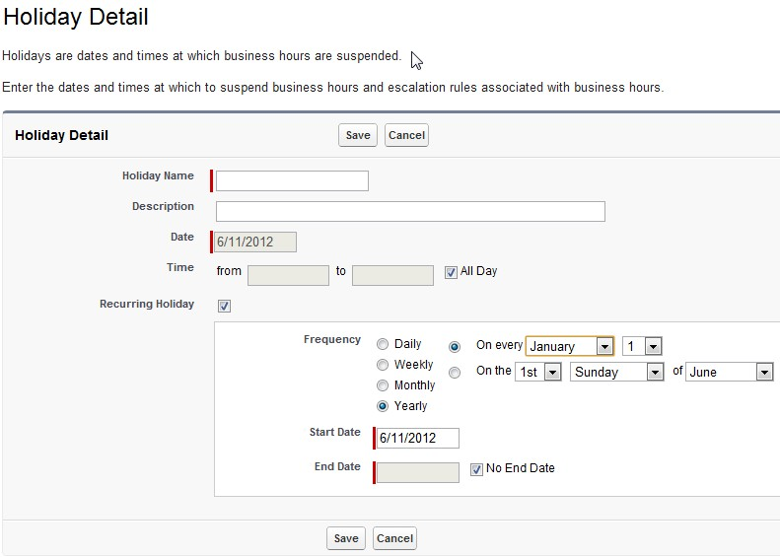

My Domain - Add a domain name to the URLs you use to log into and navigate Salesforce.com. Your domain name not only gives you another way to feature your brand, but also make your data more secure. First, choose a subdomain to register for your organization. Choose carefully, because you can only register a subdomain once for your organization. Subdomain names can include up to 40 letters, numbers, or hyphens. Your subdomain can't start or end with a hyphen.
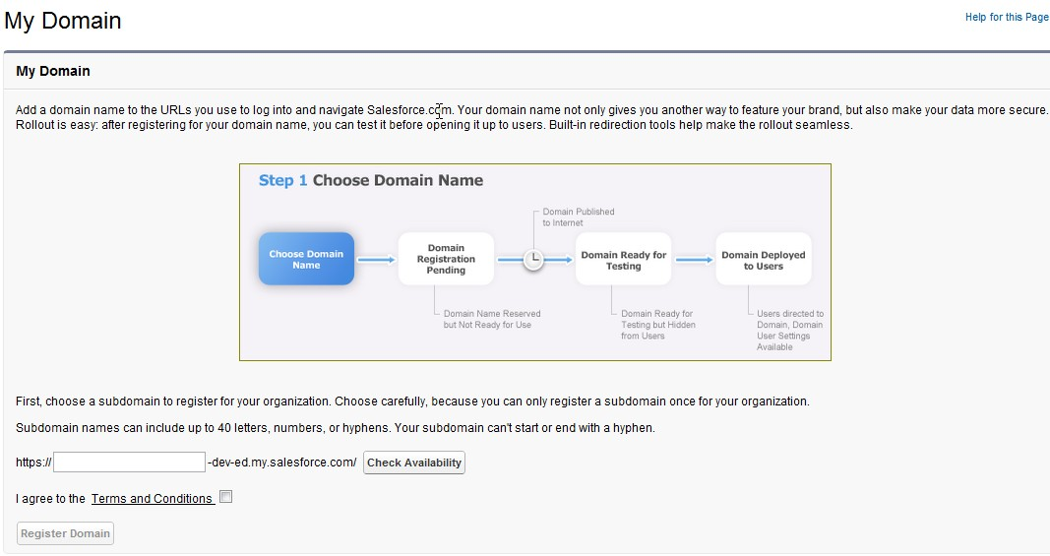

Language Settings - The Salesforce Web user interface has two language settings:
- Personal language—All on-screen text, images, buttons, and online help display in this language. Edit your personal information to change this setting.
- Default organization language—This applies to all new users until they select their personal language. This setting also determines the language in which all customizations—such as custom fields, tabs, and user interface options—are stored. For customizations, users' personal language settings don't override this default setting.

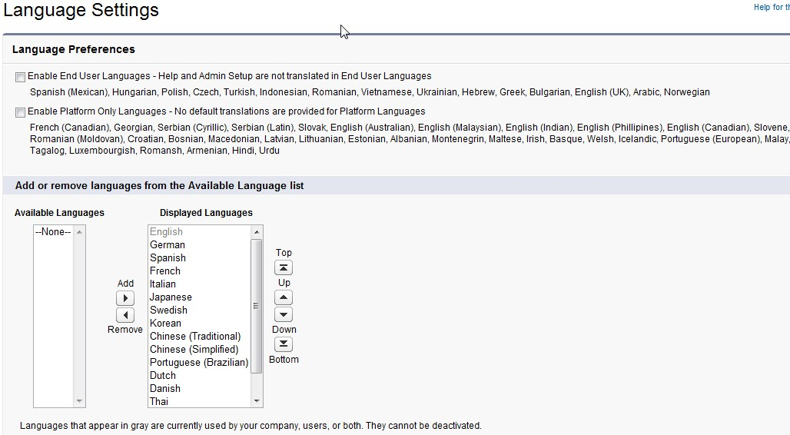

Manage Currencies – Setting Corporate Currency
The currency in which your organization’s corporate headquarters reports revenue. Serves as the basis for all currency conversion rates. A salesforce.com representative initially sets your corporate currency when activating the multiple currency feature.
To change your corporate currency:
1. Click Your Name > Setup > Company Profile > Manage Currencies.
2. Click Change Corporate.
3. Choose a new corporate currency from the list of active currencies, and click Save.
Activating and Deactivating Currencies
To use multiple currencies, you must specify which currencies are supported for your organization.
To activate new currencies:
1. Click Your Name > Setup > Company Profile > Manage Currencies.
2. Click New in the Active Currencies related list.
3. Select a currency from the drop-down. Currencies are alphabetized using their ISO currency code.
4. Enter the conversion rate relative to your corporate currency.
5. Specify the number of decimal places to display when showing amounts in this currency.
6. Click Save.

Active currency is the currency in which you company does business.
To activate a currency from the list of inactive currencies, click Activate next to the currency.
To deactivate a currency, click Deactivate.
To update the conversion rates:
1. Click Your Name > Setup > Company Profile > Manage Currencies.
2. Click Edit Rates in the Active Currencies or Inactive Currencies lists.
3. Enter the conversion rate between each currency and your corporate currency.
4. Click Save.
When you change the conversion rates, currency amounts within Salesforce are updated using the new rates.

Refer admin currency implementation guide

User Setup | 9%
Identify the steps to set up and maintain a user
Given a scenario, troubleshoot common user access and visibility issues

Ques: Identify the steps to set up and maintain a user?

Ans: To create a new user for your organization:
- Click Your Name > Setup > Manage Users > Users.
- Click New User.
- Enter the user’s first name, last name, and email address. The email address becomes the username.
- Select a User License. The profiles available to you depend on the user license you choose.
- Select a profile, which specifies the user's minimum permissions and access settings.
- Select the other options and enter the remaining user information as needed.
- If your organization has Approvals enabled, you can set the user's approver settings, such as delegated approver, manager, and preference for receiving approval request emails.
- Check Generate new password and notify user immediately to have the user’s login name and a temporary password emailed to the new user.

Maintaining a User involves the following:
Roles - Every user must be assigned to a role, or their data will not display in opportunity reports, forecast roll-ups, and other displays based on roles. If your organization uses territory management, forecasts are based on the territory hierarchy rather than the role hierarchy. Roles can control the level of visibility that users have into your organization’s data. Users at any given role level can view, edit, and report on all data owned by or shared with users below them in the hierarchy, unless your organization’s sharing model for an object specifies otherwise. When you change a user’s role, any relevant sharing rules are evaluated to add or remove access as necessary.

Permission Sets - A permission set is a collection of settings and permissions that give users access to various tools and functions. The settings and permissions in permission sets are also found in profiles, but permission sets extend users' functional access without changing their profiles. For example, to give users access to a custom object, create a permission set, enable the required permissions for the object, and assign the permission set to the users. You never have to change profiles, or create a profile for a single use case. While users can have only one profile, they can have multiple permission sets.

Profile - A profile contains user permissions and access settings that control what users can do within their organization.
Profiles control:
- Which standard and custom apps users can view
- Which tabs users can view
- Which record types are available to users
- Which page layouts users see
- Object permissions that allow users to create, read, edit, and delete records
- Which fields within objects users can view and edit
- Permissions that allow users to manage the system and apps within it
- Which Apex classes and Visualforce pages users can access
- Which desktop clients users can access
- The hours during which and IP addresses from which users can log in
- Which service providers users can access (if Salesforce is enabled as an identity provider)

Groups - Groups are sets of users. They can contain individual users, other groups, the users in a particular role or territory, or the users in a particular role or territory plus all of the users below that role or territory in the hierarchy.
There are two types of groups:
Public groups—Only administrators can create public groups. They can be used by everyone in the organization.
Personal groups—Each user can create groups for their personal use.
You can use groups in the following ways:
To set up default sharing access via a sharing rule
To share your records with other users
To specify that you want to synchronize contacts owned by others users
To add multiple users to a Salesforce CRM Content library
To assign users to specific actions in Salesforce Knowledge

Queues - Queues allow groups of users to manage a shared workload more effectively. A queue is a location where records can be routed to await processing by a group member. The records remain in the queue until a user accepts them for processing or they are transferred to another queue. You can specify the set of objects that are supported by each queue, as well as the set of users that are allowed to retrieve records from the queue. Queue is supported on Case, Leads, Service Contracts and custom Objects

Login History - On this page, Administrators can monitor the successful and failed login attempts for their organization and enabled portals. You can monitor user logins and trainings to determine who is using the application and how often and which users have taken training classes from salesforce.com. The columns on this page provide information about each login attempt made by the user. The login history page displays the most recent 20,000 entries in the login history database. If you need to see more records, you can download the information to a CSV or GZIP file.

Ques: Given a scenario, troubleshoot common user access and visibility issues?

Ans : Scenario 1
Manager of Salesforce CRM Content asks you to provide a standard user with permission to manage article types. How you will grant this permission?
Standard user profile does not have Article type permission and if you click Edit even though you cann’t provide access. You can create Clone of the user and if you edit that custom profile, you can grant the article type permission.
Clonning can help you grant access to data which a standard profile cannot provide but you have to be very careful with the permissions and must keep in mind the impact of providing that access. Always provide the minimum access to the user and then grant them access later if required. For example Director of the company asks you to provide Contract Manager with permissions to Import Leads. You can create a custom profile for him and grant him access to imports leads.
Scenario 2
Your company has appointed a person to manage accounts and remove any discrepancy if any. What permission and profile he can have?
You can create a clone of read only profile and just provide him with access to account Object. All other objects can be hidden and on Account object, give him Modify all data permissions.
Scenario 3
A user entered a wrong password to his login and made three attempts to do so and his login locked. How you can help?
Admin can go to his account under Users and reset his password.
Scenario 4
A user complains that he is receiving admin newsletter but he didn’t subscribe to them. Why he is receiving those newsletters and how can he unsubscribe?
User is receiving admin newsletter because when the user was created, the admin didn’t have unchecked the admin newsletter checkbox. Admin can go to that user details page, edit and uncheck that box. It will resolve the problem.
Scenario 5
When the user has Public Folder Access as Read/Write for Report Folder what ability does a user have?
If a user has been provided with Read/Write access to a Report Folder the user is able to save new custom reports to this folder and view the contents of the report folder. The user in not able to edit and overwrite existing reports unless they have "Manage Public Reports" permission. The user is able to modify an existing report in the report folder and "Save As" a different report in the Public Folder they have Read/Write access to.

Global User Interface | 1%
Distinguish between and identify the implications of the various user interface features that an administrator controls

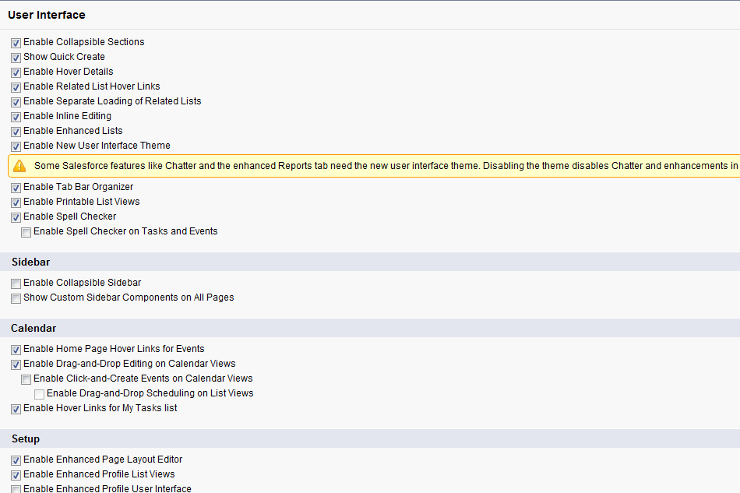

Security and Access | 15%
Explain the various organization security options
Describe the features and capabilities of the sharing model
Given a scenario, apply the appropriate security controls
Describe the various profiles controls
Given a scenario, determine the appropriate use of a custom profile

Ques: Explain the various organization security options?

Ans: Security options are managed under Security Controls that can be accessed by Name > Setup > Admin Setup > Security Controls

Security Controls
 | • Define the default sharing model for your company – Sharing settings |  | • Manage authentication providers - Auth.provider
 | • View users' access to fields – Field accessibility |  | • Configure your Identity Provider – Identity provider
 | • Define password policies for your company – Password Policies |  | • View audit trail of changes to your setup – View audit trail setup
 | • Control session settings for your users – session settings |  | • Force all of your users to reset passwords – Expire all passwords
 | • Limit IP ranges of users – Network access |  | • Delegate administration of users and custom objects – Delegated administration
 | • Control the companies your users can grant login access – Login Access settings |  | • Administer Remote Proxies – Remote site settings
 | • Create and manage certificates and keys for your organization – Certificate and key management |  | • Disallow HTML Documents and Attachments – HTML docs and attachments settings
 | • Configure single-sign on for your organization – Single sign-on settings |  | • View Portal Health Check Reports – Portal health checkup

Read sharing cheatsheet

Ques: Describe the features and capabilities of the sharing model?

Ans: Salesforce.com Application Sharing Model:

All users and application level security is defined and maintained by the organization administrator, and not by salesforce.com. The organization administrator is appointed by your organization.

Sharing Model Elements:
- Profiles
- Roles
- Hierarchy
- Record Types
- Page Layouts
- Field Level security

An organization's sharing model sets the default access that users have to each others data. There four sharing models:
- Private:
Only the record owner, and users above that role in the hierarchy, can view, edit, and report on those records. For example, if Tom is the owner of an account, and he is assigned to the role of Western Sales, reporting to Carol (who is in the role of VP of Western Region Sales), then Carol can also view, edit, and report on Tom's accounts.
- Public Read Only:
All users can view and report on records but not edit them. Only the owner, and users above that role in the hierarchy, can edit those records. For example, Sara is the owner of ABC Corp. Sara is also in the role Western Sales, reporting to Carol, who is in the role of VP of Western Region Sales. Sara and Carol have full read/write access to ABC Corp. Tom (another Western Sales Rep) can also view and report on ABC Corp, but cannot edit it.
- Public Read/Write:
All users can view, edit, and report on all records. For example, if Tom is the owner of Trident Inc., all other users can view, edit, and report on the Trident account. However, only Tom can alter the sharing settings or delete the Trident account.
- Public Read/Write/Transfer:
All users can view, edit, transfer, and report on all records. Only available for cases or leads. For example, if Alice is the owner of ACME case number 100, all other users can view, edit, transfer ownership, and report on that case. But only Alice can delete or change the sharing on case 100.

Profiles:
A profile defines a users permission to perform different functions within salesforce.com. Profiles also control the following:
- Which page layouts the user sees
- The field-level security access that the user has to view and edit specific fields
- Which tabs the user can view
- Which record types are available to the user
- The hours and IP addresses from which the user can log in
- Administrators, and users with the "Manage Users" permission, can create, edit, and delete profiles

Roles
Every user must be assigned to a role, or their data will not display in opportunity reports, forecast rollups, and other displays based on roles.
- All users that require visibility to the entire organization should be assigned the highest level in the hierarchy.
- It is not necessary to create individual roles for each title at your company, rather you want to define a hierarchy of roles to control access of information entered by users in lower level roles.
- When you change a user's role, any relevant sharing rules are reevaluated to add or remove access as necessary.

Record Types
If your organization uses record types, edit the record type to modify which pick list values are visible for the record type. You can set default pick list values based upon the record type for various divisions.

Field Level Security
Field-level security settings let administrators restrict users. access to view and edit specific fields on detail and edit pages and in related lists, list views, reports, Offline Edition, search results, email and mail merge templates, Custom Links, and when synchronizing data.

The Sharing model allow users to:
1. Organization-wide defaults determine the default level of access that users have to leads, contacts, accounts (including contracts and assets), opportunities, cases, activities, campaigns, custom objects, and price books.
2. If a role hierarchy is set up, managers can access any records that their subordinates can access.
3. Administrators can create sharing rules that give users access to records, beyond the organization-wide defaults. Sharing rules specify the type of access (such as read or read/write) between public groups, roles, and roles & subordinates.
4. Public groups can contain other groups. This makes group administration easier since the admin can maintain a base-level group. When a base-level group is included in a sharing rule, every group that contains that group is automatically updated.
5. In the sharing model, you can easily see everyone who has more access to your record than the org-wide default gives them and why.

Ques: Describe the various profiles controls?

Ans: A profile contains user permissions and access settings that control what users can do within their organization. For example, permissions determine a user's ability to edit an object record, view the Setup menu, empty the organizational recycle bin, or reset a user's password.
Access settings determine other functions, such as access to Apex classes, app visibility, and the hours when users can log in.
Permissions and access settings are specified in user profiles and permission sets. Every user is assigned only one profile, but
can also have multiple permission sets.
When determining access for your users, it's a good idea to use profiles to assign the minimum permissions and access settings
for specific groups of users, then use permission sets to grant additional permissions. You can use profiles and permission sets to grant access, but not to deny access. Any permission granted from either a profile or permission set is honored. For example, if “Transfer Record” isn't enabled in Jane Smith's profile, but is enabled in two of her permission sets, she can transfer records regardless of whether she owns them.

Profiles control:
• Which standard and custom apps users can view
• Which tabs users can view
• Which record types are available to users
• Which page layouts users see
• Object permissions that allow users to create, read, edit, and delete records
• Which fields within objects users can view and edit
• Permissions that allow users to manage the system and apps within it
• Which Apex classes and Visualforce pages users can access
• Which desktop clients users can access
• The hours during which and IP addresses from which users can log in
• Which service providers users can access (if Salesforce is enabled as an identity provider)

Standard and Custom Objects | 18%
Describe the standard object architecture and relationship model
Explain how to create, delete, and customize fields, page layouts, and list views for custom and standard objects
Given a scenario, determine the appropriate fields and page layouts for custom and standard objects
Explain how to create, delete, and customize record types for custom and standard objects
Given a scenario, determine the appropriate record types and business processes for custom and standard objects
Explain the implications of deleting fields
Describe when to use and how to create formula fields

Ques: Describe the standard object architecture and relationship model?

Ans: Standard object architecture has the following elements:
- Standard Fields
- Custom Fields & Relationships
- Validation Rules
- Triggers
- Page Layouts
- Field Sets
- Search Layouts
- Standard Buttons and Links
- Custom Buttons and Links
- Record Types
- Related Lookup Filters
- Object Limits

There are different types of relationships between objects in Salesforce. Their differences include how they handle data deletion, sharing, and required fields in page layouts:
Master-detail
This type of relationship closely links objects together such that the master record controls certain behaviors of the detail and subdetail record. For example, you can define a two-object master-detail relationship, such as Account—Expense Report, that extends the relationship to subdetail records, such as Account—Expense Report—Expense Line Item. You can then perform operations across the master—detail—subdetail relationship.
Behaviors of master-detail relationships include:
- When a master record is deleted, the related detail and subdetail records are also deleted.
- By default, records can’t be reparented in master-detail relationships. Administrators can, however, allow child records in master-detail relationships on custom objects to be reparented to different parent records by selecting the Allow reparenting option in the master-detail relationship definition.
- The Owner field on the detail and subdetail records is not available and is automatically set to the owner of the master record. Custom objects on the “detail” side of a master-detail relationship can't have sharing rules, manual sharing, or queues, as these require the Owner field.
- The security settings for the master record control the detail and subdetail records.
- The master-detail relationship field (which is the field linking the objects) is required on the page layout of the detail and subdetail records.
- The master object can be a standard object, such as Account or Opportunity, or a custom object.
- As a best practice, don't exceed 10,000 child records for a master-detail relationship.
Many-to-many
You can use master-detail relationships to model many-to-many relationships between any two objects. A many-to-many relationship allows each record of one object to be linked to multiple records from another object and vice versa. For example, you may have a custom object called “Bug” that relates to the standard case object such that a bug could be related to multiple cases and a case could also be related to multiple bugs. See Creating a Many-to-Many Relationship.
Lookup
This type of relationship links two objects together. Lookup relationships are similar to master-detail relationships, except they do not support sharing or roll-up summary fields. With a lookup relationship, you can:
- Link two different objects.
- Link an object with itself (with the exception of the user object; see Hierarchical). For example, you might want to link a custom object called “Bug” with itself to show how two different bugs are related to the same problem.
- When you create a lookup relationship, you can set these options:
  - Make the lookup field required for saving a record, requiring it on the corresponding page layout as well.
  - If the lookup field is optional, you can specify one of three behaviors to occur if the lookup record is deleted:
  - Clear the value of this field This is the default. Clearing the field is a good choice when the field does not have to contain a value from the associated lookup record.
  - Don’t allow deletion of the lookup record that’s part of a lookup relationship This option restricts the lookup record from being deleted if you have any dependencies, such as a workflow rule, built on the relationship.
  - Delete this record also Available only if a custom object contains the lookup relationship, not if it’s contained by a standard object. However, the lookup object can be either standard or custom. For example, say you have an expense report record with a lookup relationship to individual expense records. When you delete the report, you probably want to delete all of the expense records, too.
- When you define a lookup relationship, you have the option to include a lookup field on the page layouts for that object as well as create a related list on the associated object's page layouts. For example, if you have a custom object called “PTO Requests” and you want your users to link a PTO request with the employee submitting the request, create a lookup relationship from the PTO Request custom object with the user object.
Hierarchical
This type of relationship is a special lookup relationship available only for the user object. It allows users to use a lookup field to associate one user with another that does not directly or indirectly refer to itself. For example, you can create a custom hierarchical relationship field to store each user's direct manager.

Ques: Explain how to create, delete, and customize fields, page layouts, and list views for custom and standard objects?

Ans: Fields

To create new field for standard objects
- Go to Name > Setup> App Setup > Customize > Object(Account) > Fields
- Click New in Accounts Custom Fields and relationships
- Select data type for the field. For example, select text, number, date, picklist, formula etc.
- Enter the details such as field label, field name, description, help text etc
- Establish Field level security where you can select profiles to whom you want to grant access via field level security.
- Select Page layouts where you want this field to appear.
- Click Save
To delete field, click Del in actions under Accounts Custom Fields and relationships
To edit, click edit in actions under Accounts Custom Fields and relationships where you can modify the attributes.
You can add field dependencies to the fields. Create a dependent relationship that causes the values in a picklist or multi-select picklist to be dynamically filtered based on the value selected by the user in another field.
  - The field that drives filtering is called the "controlling field." Standard and custom checkboxes and picklists with at least one and less than 300 values can be controlling fields.
  - The field that has its values filtered is called the "dependent field." Custom picklists and multi-select picklists can be dependent fields.

To create fields in custom object
- Go to Name > Setup > App Setup > Create > Object and select one of the custom object.
- Click New in Custom fields and relationships
- Select data type for the field. For example, select text, number, date, picklist, formula etc.
- Enter the details such as field label, field name, description, help text etc
- Establish Field level security where you can select profiles to whom you want to grant access via field level security.
- Select Page layouts where you want this field to appear.
- Click Save
To delete field, click Del in actions under Custom Fields and relationships
To edit, click edit in actions under Custom Fields and relationships where you can modify the attributes.
You can add field dependencies to the fields.

Page Layout

To create new page layout for standard objects:
- Go to Name > Setup > App Setup > Customize > Object > PageLayout
- Click New to create one
- In the enhanced page layout editor, click Edit next to a layout, and then click Save As on the layout page.
- In the original page layout editor, select a layout, and then click Clone on the layout page.
- Enter name for the layout and click Save.
Click Edit to modify layouts.
Click Del to delete layouts.
Click Page Layout Assignment to assign page layouts to profiles and record types.

To create new page layout for custom objects:
- Go to Name > Setup > App Setup > Create > Object and select one of the custom object
- On the Page Layout related list, click New to create one

Search Layout (list View)

Customize which fields display for users in search results, search filter fields, lookup dialogs, the recent records lists on tab home pages, and in lookup phone dialogs for Salesforce CRM Call Center. You can specify a different set of fields to show in each search layout. The settings apply to all users in your organization and Salesforce Customer Portal.
- Go to Name > Setup > App Setup > Customize > Object > Search Layouts
- Click Edit next to the layout you want to customize. You can specify a different set of items to display for search results, lookup dialogs, recent records lists on tab home pages, lookup phone dialogs, list views, and search filter fields.
- For list view and search results layouts, select any standard or custom buttons you want to display. To hide a standard button on the list view, deselect it. Standard buttons are not available on search result layouts.
- Use the arrows to add or remove items from the layout, and to define the order in which the fields should display. To select more than one item, use CTRL+click or SHIFT+click to select multiple items in a range.
  - Select one or more items in the available list and click Add to add them to the layout.
  - Select one or more items in the selected list and click Remove to remove them from the layout.
  - Select one or more items in the selected list and click Up to move them higher in the list.
  - Select one or more items in the selected list and click Down to move them lower in the list.
- Click Save.

Ques: Explain how to create, delete, and customize record types for custom and standard objects?

Ans: Record types allow you to offer different business processes, picklist values, and page layouts to different users based on their profiles. Record types can be used in various ways, for example:
Create record types for opportunities to differentiate your regular sales deals from your professional services engagements and offer different picklist values for each.
Create record types for cases to display different page layouts for your customer support cases versus your billing cases.
The following special picklist fields are not available for record types because they are used exclusively for sales processes, lead processes, support processes, and solution processes:
- Opportunity Stage
- Case Status
- Solution Status
- Lead Status

To create new record type:
- Go to Name > Setup > App Set up > Customize > Object > Record types
- Click New
- Enter a name and description for the new record type. The new record type will include all the picklist values from the existing record type selected.
- Select Master. Make the record type Active.
- Select the Enable for Profile checkbox to make the new record type available to a profile. Users assigned to this profile will be able to create records of this record type, or assign this record type to existing records. To make the new record type the default for a profile, select the Make Default checkbox.
- Select the page layout that users with this profile see for records with this record type. You have two options:
- Apply single layout to all profiles
- Apply different layout to each profile
- After saving, choose the picklist values that are available with this record type.
To edit picklists, select an item from the Available Values list and add it to the Selected Values list to include it as a picklist value for this Record Type. Note that removing an item from the picklist does not remove it from any existing records. Finally, select a default picklist value for this Record Type. For example, picklist for account source is there where you have picklist values as web, phone enquiry, partner referral, purchase and other. Select which one needs to appear as default value.

For Opportunities, Leads, Solution and Cases, there are business processes related to these objects. So when you create a record type, you can associate that record type to the business process.

Scenario:
A company has three divisions – Hardware, Consulting and Software. VP of each division wants customize sale processes for them. How you will accomplish this?

First create the sale process by for Opportunities object. When you click New, enter the name, label and description for the process. In the next step, you will get the Stage picklist for editing. In Opportunities, Stage(picklist) defines the Sales cycle that it will follow. So you can select the values as per the requirement for each division. Once the sale process is created, go to record types and create new record type and now in the first step of enter the details, you will get the option to select the sale process. Add the sale process respectively and then you can also edit the picklists that are there for the record type to suit the need of the divisions.

Ques: Explain the implications of deleting fields?

Ans: To delete a custom field:
For standard objects, click Your Name > Setup > Customize> Object > Fields
For custom objects, click Your Name > Setup > Create > Objects, and select one of the custom objects in the list.
Click Del next to the name of the field.
When prompted, select the Yes, I want to delete the custom field checkbox to confirm, and click Delete.
In order to preserve a record of data for future reference, run a data export before deleting custom fields by clicking Setup | Data Management | Data Export.
After you have deleted this field, it appears in the deleted fields list where you can either undelete it to restore the field and all data stored in it, or erase it to permanently delete it and all its data. Note that when you undelete a field, some properties on the field will be lost or changed.
You will have 15 days to undelete this field to restore the field and all data stored in it, and after that time it and all data stored in it will be automatically permanently deleted.

Implications:
- Deleting will delete all dependent information for any dependent or controlling field
- Deleting will change the result of Assignment or Escalation Rules that rely on the custom field data
- Before deleting a custom field, consider where it is referenced. You can’t delete a custom field that is referenced elsewhere. For example, you cannot delete a custom field that is referenced by a field update.
- When you delete a custom field, all of the field history data is deleted and changes are no longer tracked.
- A background process periodically runs that cleans up metadata associated with deleted custom fields. This process will affect the Last Modified Date and Last Modified By fields on page layouts, record types, and custom objects.

Deleting Custom Objects
When you delete a custom object, Salesforce does not add it to the Recycle Bin with other deleted records. Instead, deleted objects appear in the Deleted Custom Objects list for 15 days. During this time you can restore an object and the data stored in it, or permanently erase the object and its data. After 15 days, the object and its data are permanently erased. If a user clicks a bookmark to a deleted custom object record's URL, Salesforce displays an Insufficient Privileges message. If you’re approaching your limit for custom objects and need to delete some to create room for more, you need to hard delete or erase them. Soft-deleted custom objects and their data count against your limits.
Implications:
When you delete a custom object, Salesforce does the following:
- Removes the object from Force.com AppExchange packages.
- If the deleted object is on the detail side of a master-detail relationship, changes the master-detail relationship to a lookup relationship.
- Permanently erases:
  - The object's data records currently in the Recycle Bin
  - Custom tab, which is removed from any custom apps
  - List views for the object
  - Workflow rules and actions that use the object
  - Mobile configuration settings, including data sets, mobile views, and excluded fields
- If the deleted object is on the detail side of a master-detail relationship:
  - Standard report types associated with this object
  - Reports based on standard report types
- Hides, inactivates, or disables:
  - The custom object definition and all related definitions
  - The object's data records and all related data records
  - Custom report types for which this is the main object
  - Custom reports for which this is the main object
  - Custom formula fields on the object
  - Custom validation rules and approval processes on the object
Salesforce restores these items if you restore the custom object.
- You can't delete a custom object if it is on the master side of a master-detail relationship. When you delete a custom object that is on the detail side of a master-detail relationship, the relationship is converted to a lookup relationship. If you restore the custom object, you must manually convert it to a master-detail.
- You can't delete a custom object if it is a target object in an analytic snapshot.
- You can't delete a custom object that contains custom fields that are used in a roll-up summary field for another object.
- Page layouts on a custom object are deleted and restored with it. However, custom object data can also exist on page layouts for other objects in the form of related lists. These related lists remain until you edit the page layout, at which time Salesforce permanently removes any items relating to the deleted custom object.
- You can't delete a custom object if it is referenced in:
  - Apex
  - A Visualforce page
  - An analytic snapshot
- In a many-to-many relationship, a user can't delete a parent record if there are more than 200 junction object records associated with it and if the junction object has a roll-up summary field that rolls up to the other parent. To delete this object, manually delete junction object records until the count is fewer than 200.
- You can't delete more than 100,000 combined objects and child records at the same time. To delete an object that has more than 100,000 child records, first delete an appropriate number of its child records.

Ques: Describe when to use and how to create formula fields?

Ans: A formula is an algorithm that derives its value from other fields, expressions, or values. Building a formula follows the same steps as for creating custom fields.

- Go to Name > Setup > Appsetup > Customize > Object > fields > New field
- Select the data type for the formula. Choose the appropriate data type for your formula based on the output of your calculation. See Formula Data Types.
- Choose the number of decimal places for currency, number, or percent data types. This setting is ignored for currency fields in multicurrency organizations. Instead, the Decimal Places for your currency setting apply.
Note: Salesforce uses the round half up tie-breaking rule for numbers in formula fields. For example, 12.345 becomes 12.35 and −12.345 becomes −12.34.
- Click Next.
- Build your formula:
  - If you are building a formula in the Advanced Formula tab or for approvals or rules, such as workflow, validation, assignment, auto-response, or escalation, click Insert Field, choose a field, and click Insert.
  - To create a basic formula that passes specific Salesforce data, select the Simple Formula tab, choose the field type in the Select Field Type drop-down list, and choose one of the fields listed in the Insert Field drop-down list.
  - To insert an operator, choose the appropriate operator icon from the Insert Operator drop-down list. Use the examples in Operators and Functions.
  - Optionally, click the Advanced Formula tab to use functions and view additional operators and merge fields. Functions are prebuilt formulas that you can customize with your input parameters. For a description of each operator and function, see Operators and Functions.
  - To insert a function, double-click its name in the list, or select it and click Insert Selected Function. To filter the list of functions, choose a category from the Functions drop-down list. Select a function and click Help on this function to view a description and examples of formulas using that function.
- Click Check Syntax to check your formula for errors.
- Optionally, enter a description of the formula in the Description box.
- If your formula references any number, currency, or percent fields, choose an option for handling blank fields. To give any blank fields a zero value, choose Treat blank fields as zeros. To leave these fields blank, choose Treat blank fields as blanks.
- Click Next.
- Set the field-level security to determine whether the field should be visible for specific profiles, and click Next.
- Choose the page layouts that should display the field. The field is added as the last field in the first two-column section on the page layout. For user custom fields, the field is automatically added to the bottom of the user detail page.
- Click Save to finish or Save & New to create more custom fields.

Custom summary formula:
Custom summary formulas can contain 3900 or fewer characters. Custom summary formulas are available for summary, matrix, and joined reports. They can't be shared across multiple reports.
- In report builder, click Add Formula in the Fields pane.
- Enter a name for your formula as it will appear on the report. The label must be unique. Optionally, enter a description.
- From the Format drop-down list, select the appropriate data type for your formula based on the output of your calculation. See Formula Data Types for more information on formula data types.
- From the Decimal Places drop-down, select the number of decimal places to display for currency, number, or percent data types. This setting is ignored for currency fields in multicurrency organizations. Instead, the Decimal Places for your currency setting apply.
If you select None for Decimal Places, the effective values are:
  - For currency, displays up to 18 digits, with the default decimal-place precision for the currency
  - For percentages, displays up to 18 digits, with no decimal places
  - For numbers, displays up to 18 digits, without changing the decimal-place precision
- Set the Where will this formula be displayed? option. The formula calculation will be displayed in the report at the level you select. To display the formula calculation at every level, including the Grand Total, select All summary levels.
- Build your formula:
  - Select one of the fields listed in the Summary Fields drop-down list. This field’s value is used in your formula.
  - Select the kind of summary type to use in your formula. This option is not available for Record Count
Summary Type | Description
Sum | The summary value of data in a field or grouping of fields.
Largest Value | The largest value of data in a field or grouping of fields.
Smallest Value | The smallest value of data in a field or grouping of fields.
Average | The average of data in a field or grouping of fields.
  - Click Operators to add operators to your formula.
  - Select the function category (All, Logical, Math, or Summary), choose the function you want to use in your formula, and click Insert.
  - Repeat these steps as necessary.
- Click Check Syntax to see if your formula contains errors. Errors are highlighted by the cursor.
- Click OK. Your formula isn't saved until you save the report.

Cross Object formulas
Cross-object formulas are formulas that span two related objects and reference merge fields on those objects. Cross-object formulas can reference merge fields from a master (“parent”) object if an object is on the detail side of a master-detail relationship. You can reference fields from objects that are up to ten relationships away. Cross-object formulas are available anywhere formulas are used except when creating default values.
To create a cross-object formula when building a formula in the Simple Formula tab, enter the relationship names of the objects to which you are spanning followed by the field you want to reference. Separate the relationship names of each object and the field with periods.
For example, enter Contact.Account.Name to reference the Account Name for a contact associated with a case in a formula field on the Case object. Be sure to use the relationship names of the objects, not the labels. Although the relationship name is often the same as the object name, it is technically the field name of the relationship field. For example, to reference the parent account name from Account object, the syntax is Parent.Name, not Account.Name. Also, when referencing a custom object, add two underscores and the letter r to its name. For example, Position__r.title__c references the Job Title field (title__c) on a Position custom object.
To create a cross-object formula when building a formula in the Advanced Formula tab or for approvals or rules, such as workflow, validation, assignment, auto-response, or escalation rules, click Insert, then click the related object to list its fields. Related objects are denoted by a “>” sign.

Tips on building formulas:
- Formula fields can contain up to 3,900 characters, including spaces, return characters, and comments. If your formula requires more characters, create separate formula fields and reference them in another formula field. The maximum number of displayed characters after an evaluation of a formula expression is 1,300 characters.
- Formulas on Activities that use standard fields—either alone or in workflow rules—shouldn't be placed on both the Task and Event pages. This is because both Tasks and Events are considered Activities.
- Formulas are automatically created.
- A summary formula can't reference another summary formula.
- “#Too Big!” displays on report cells if your custom summary formula output exceeds 21 digits and for custom formula field output should not exceed 18 digits. When this happens, check your formula for calculations that could result in more than 18 digits. Avoid multiplying large numbers, raising a large number to a power, or dividing by a very small number.
- Formulas treat blank (null) report cells as zero values.
- “#Error!” displays on report cells whenever an error occurs while calculating a formula’s value. “#Error!” also displays when formulas divide by zero. To resolve the error, check your formula and provide an alternative value.
- Salesforce allows a maximum of ten unique relationships per object in cross-object formulas.
- You cannot reference cross-object formulas in roll-up summary fields.

Scenario: Calculate Account Commission based on Expected Revenue of the Opportunity and display that on Opportunity details page.
Commission calculation:
if
(stage=closed won & Expected Revenue>$100,000)
then
commission=3%*Expected Revenue
else
commission=0)
Formula: IF( AND( ISPICKVAL( StageName , "Closed Won"), ExpectedRevenue > 100000) , ROUND(0.03 * ExpectedRevenue,2) , 0)

Read Formula : How do I

Sales Cloud Applications | 9%
Given a scenario, identify the capabilities and implications of the sales process
Given a scenario, identify when to apply the appropriate sales productivity features
Describe the capabilities of products and price books
Describe the capabilities of lead management
Given a scenario, identify how to automate lead management
Describe the capabilities of campaign management

Ques: Given a scenario, identify the capabilities and implications of the sales process?

Ans: For example, your company may have three sales divisions: hardware, software, and consulting. The hardware and software divisions follow a 10-step sales process they call Miller Heiman. But consulting follows an 8-step sales process they call Strategic Selling so users of that division never use the Prospecting or Perception Analysis stages during the sales cycle. To manage these different sales processes, create two sales processes and include the Prospecting and Perception Analysis stages in only one of them.
To set this up, the administrator can do the following:
- Manage master picklists
Define the complete list of opportunity Stage picklist values that you plan to use across the hardware, software, and consulting divisions.
- Create sales processes
Create two sales processes: Miller Heiman and Strategic Selling. Include the Prospecting and Perception Analysis stage values in the sales process Miller Heiman, but exclude them from the sales process Strategic Selling.
- Create record types and associate them with business processes.
Create three record types: Hardware, Software, and Consulting Associate both the Hardware and Software record types with the Miller Heiman sales process. Associate the Consulting record type with the Strategic Selling sales process.
- Add record types to profiles
Add the Hardware record type to the profiles of all users in your hardware sales division. Add the Software record type to the profiles of all users in your software sales division. Finally, add the Consulting record type to profiles of all users in your consulting sales division. If your hardware sales division cross sells software and consulting, add the Software and Consulting record types to the user profile for hardware sales users.

Ques: Given a scenario, identify when to apply the appropriate sales productivity features?

Ans: Sales productivity features includes: Team selling and sales methodologies.
For example, VP of sales asks you to include five member to his team which includes sales manager, sales rep of eastern division, marketing head of western sales, technical architect and VP of marketing. How you will accomplish this?
You can create a default sales team for him so that whenever he wants this team can work with him. These roles have different access permissions but when they are setup as a sales team they have the same level of access to work on the opportunities. So no need to worry about permission denied etc and thus improving productivity.

To create Default Sales team, first go to Customize > Opportunities > Team selling opportunities.
Check if Team Selling is enabled, if not enable it.
Once it is enabled, user can go his personal Information setup and create his default sales team.
Go to Default Sales Team related list under personal information link.
Click Add.
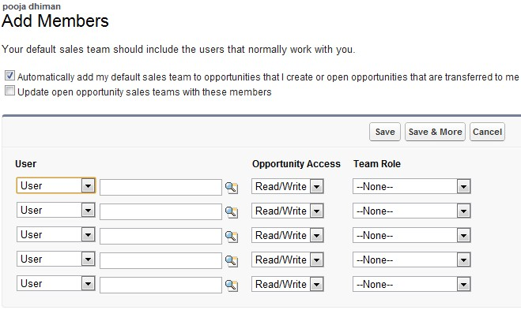

There are different sales methododlogies available:
- Miller Heiman
- Solution Selling
- The Complex Sales Inc.
- The TAS group
- Big machines
All these sales methodologies provide apps that seamlessly integrate with Salesforce. As per the requirement, organization can utilize these options.

Ques: Describe the capabilities of products and price books?

Ans: Products are the individual items that you sell on your opportunities and quotes.
A price book contains products and their associated prices. Each product with its associated price is referred to as a price book entry. You can use the standard price book or create custom price books. The standard price book is automatically generated to contain a master list of all products and standard prices regardless of the custom price books that also contain them.
Schedules - You can establish default schedules on a product, as well as schedules for individual line items (opportunity products) on an opportunity. Your administrator determines which types of schedules your organization can use: quantity schedules, revenue schedules, or both. Your administrator also specifies which types of schedules can be established for each separate product.
- Quantity Schedule–Outlines the dates, number of units, and number of installments for payments, shipping, or other use as determined by your organization.
- Revenue Schedule–Outlines the dates, revenue amounts, and number of installments for payments, recognizing revenue, or other use.
It is a best practice to enable schedule setup before creating product.
- Go to Customize > Products > Schedule Setup.
- Enable Quantity schedule and Revenue schedule if you want both of them or enable as required. If you don’t enable either of them then the disabled schedule will not appear on the product page.
- Go to Products and click new to create new product.
- Enter the name and description and define schedule.
- After creating product you can add price to it.
Optionally, you also can:
- Click Add in the Standard Price related list to add an associated price and currency to the new product.
- Click Add to Price Book from the Price Books related list to include the new product in a price book. Products must have a standard price before you can add them to a price book.

There are three types of prices
- Standard Prices are the default list prices you associate with products and are automatically included in your Standard Price Book.
- List Prices are the prices associated with products in your custom price books.
- Sales Prices are the prices applied to products that you add to your opportunities or quotes. Sale prices can be different than both list prices and standard prices.
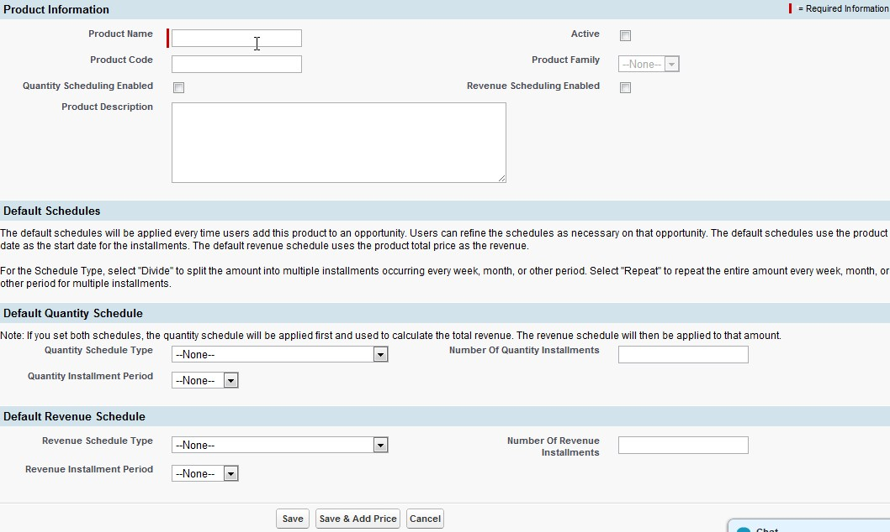

To create a custom price book for your organization:
- In the Maintenance section on the Products home page, click Manage Price Books.
- Click New.
- Enter a name for your price book.
- Optionally, enter a description.
- Check Active to make the price book available from opportunities and quotes.
- Optionally, select an existing price book to add its products and prices to the new price book.
- Click Save.

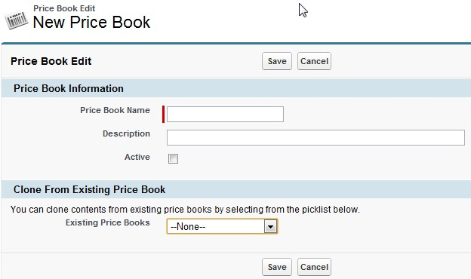

Adding Products to the opportunity:
- First choose price book that contains the associated product.
- Once price book is selected you will be prompted to select the product in that price book. You can select the appropriate product
- Type the Sales Price for the product.
- Type the number of products at the current sales price in the Quantity field.

Tips:
- If the opportunity product has a revenue or quantity schedule, you can’t edit the Discount field.
- If you delete the price book of an opportunity then all the products listed in that pricebook will be deleted from the related list but Amount field will remain ineffective.
- If an opportunity is synced with a quote, deleting products from the opportunity also deletes the line items from the Quote Line Items related list for the corresponding quote.
- You can't delete a product if cases, service contracts, or contract line items are associated with it.
- You can't delete a product or price book that's associated with an approval process or has a pending workflow action

For Validation rules refer https://salesforce.adobeconnect.com/_a13852757/customvalidationformulas/
Ques: Describe the capabilities of lead management?

Ans: Lead management helps your inside sales or telesales teams qualify leads before passing them on to sales. Sales reps get instant access to the latest prospects and ensures that leads are never dropped. You can:

- Acquire leads by importing, creating manually, or automatically capturing them from your website.
- Automatically assign leads using assignment rules based on geography, source, or other attributes.
- Easily convert leads that you identify as a real sales opportunities into an accounts, contacts, and opportunities.

Capabilities:
Assigning Leads
You can automatically assign imported or Web-generated leads to users or queues using lead assignment rules based on region, product, or other lead criteria.
Lead Queues
• Use lead queues to manage lead distribution
• Create queues for different teams and assign different reps as members of each queue
• Queue members can take ownership of leads that are in queues of which they are a member
Web-to-Lead
You can capture leads directly from your website using Web-to-Lead. With Web-to-Lead, you can capture up to 500 leads per day. To increase this limit, contact salesforce.com.
Web-to-Lead Auto-Response Rules
Set up Web-to-Lead Auto-Response rules with conditions that determine which email template to use when responding to leads captured from your website. The rule conditions can be based on any attribute of the incoming lead, including campaign name and status.
Importing Leads
Administrators and users with the “Import Leads” permission can import a file of up to 50,000 leads from Your Name > Setup > Data Management > Import Leads.
Custom Fields and Mapping
• Set up custom fields for imported data that does not match standard fields
• Create custom fields for non-standard fields to be filled in with Web-to-Lead
• When converting leads, you can map custom lead fields to custom fields in opportunities, contacts, or accounts

Notes on Field mapping when converting leads:
If you are not using custom fiscal years, the Close Date of the newly created opportunity is automatically set to the last day of the current fiscal quarter.
If you are using custom fiscal years, the Close Date is the last day of the current fiscal period. If you are using custom fiscal years and a fiscal year has not been defined for the current date, the Close Date is the end of the current calendar quarter.
Remember to map custom lead fields to other custom fields of the same data type, that is, map numeric lead fields to other numeric fields or long text area fields to other long text area fields.
Some exceptions are:
- You can map between text and picklist fields. However, your data may become truncated if the mapped text field is not large enough to hold the entire lead picklist value.
- You can map fields of type Text or Text Area to long text area fields
- You can map auto-number fields to fields of type Text, Text Area, or Picklist.
- Do not map custom formula fields to other formula fields or any other type of field.
- Roll-up summary fields are not available for mapping lead fields of converted leads.
Remember to map custom lead fields of type number, currency, or percent to other number, currency, or percent fields of exactly the same length and decimal places. For example, if your lead currency field has a length of 3 and 2 decimal places, map it to another custom currency field with a length of 3 and 2 decimal places.
Any standard lead picklist fields that are blank are mapped to the default picklist values for the account, contact, and opportunity.

If you change the data type of any custom field used for lead conversion, that lead field mapping will be deleted.

When you convert a lead, Salesforce creates a new account, contact, and, optionally, an opportunity using the information from the lead. Any campaign members are moved to the new contact and the lead becomes read only. If an existing account and contact have the same names as those specified on the lead, you can choose to update the existing account and contact. Information from the lead is inserted only into blank fields; Salesforce does not overwrite existing account and contact data.
All open and closed activities from the lead are attached to the account, contact, and opportunity. You can assign the owner of the records, and schedule a follow-up task. When you assign a new owner, only the open activities are assigned to the new owner. If you have custom lead fields, that information can be inserted into custom account, contact, or opportunity fields. Converted leads can't be viewed, although they appear in lead reports. Salesforce updates the Last Modified Date and Last Modified By system fields on converted leads when picklist values included on converted leads are changed.

If you have a trigger set to fire when new records are created, the trigger temporarily assigns a system user as the owner of the created records. After the trigger finishes, the owner is set to the lead owner.

Also read Converting Leads

Ques: Given a scenario, identify how to automate lead management?

Ans: To set up Web-to-Lead:
Click Your Name | Setup | Customize | Leads | Web-to-Lead.
Click Edit to enable or modify the following Web-to-Lead settings:
- Web-to-Lead Enabled - Enables Web-to-Lead.
- Default Lead Creator - The user who will be listed as the creator of online leads and who will appear as the sender of email responses. This user must have the System Administrator profile or the “Modify All Data” and “Send Email” permissions.
- Default Response Template - The default response template to use for the email response that is automatically sent to prospects when they submit an online lead.
If you set up response rules to use different email templates based on the information submitted, the default response template is used when no auto-response rules apply. Leave this option blank if you do not wish to send emails when no response rules apply. This template must be marked as “Available for Use.”
Click Save.
To create a Web-to-Lead form
- Click Create Web-to-Lead Form on the Web-to-Lead Setup page.
- Select fields to include on your Web-to-Lead form. Use the Add and Remove arrows to move fields between the Available Fields list and the Selected Fields list, and use the Up and Down arrows to change the order of the fields on your form.
- Select the Campaign field (and optionally, the Campaign Member Status field) if you are using Web-to-Lead as part of a campaign.
- For organizations using multiple currencies, add the Lead Currency field if you add currency amount fields, otherwise all amounts will be captured in your corporate currency.
- Use a custom multi-select picklist to allow potential customers to express interest in several products.
- For organizations using lead record types, select the Lead Record Type field if you want users to select a record type for Web-generated leads.
- If your organization uses the Translation Workbench or has renamed tabs, select the language for the form labels displayed on your Web-to-Lead form. The source of your Web-to-Lead form is always in your personal language.
- Specify the complete URL to which users should be directed after they submit their information—for example, your company's home page for a thank you page—and click Generate.
- Copy the generated HTML code and provide it to your company's webmaster to incorporate into your website.
- Click Finished.
To test the Web-to-Lead form, add the line <input type="hidden" name="debug" value="1"> to your code. This line redirects you to a debugging page when you submit the form. Remove this line before releasing the Web-to-Lead page to your website.
Leads generated from your website are initially marked with the “default status” specified by the Lead Status picklist. For Web leads generated as part of a campaign, the member status of the new leads is set to the Member Status value specified in the form, or to the “default” member status if the Member Status field is not included in the form.
In addition, new leads are marked as “Unread,” and are changed to “Read” when viewed or edited by the lead owner. Users can select the My Unread Leads list view to quickly locate their new leads.
Note:
- The format for date and currency fields captured online is taken from your organization’s default settings - Default Locale and Currency Locale.
- The daily limit for Web-to-Lead requests is 500. If your organization exceeds its daily Web-to-Lead limit, the Default Lead Creator (specified in the Web-to-Lead setup page) receives an email containing the additional lead information.
- If a new lead cannot be generated due to errors in your Web-to-Lead setup, Customer Support is notified of the problem so that we can help you correct it.
- Salesforce runs field validation rules before creating records submitted via Web-to-Lead and only creates records that have valid values.
- All universally required fields must have a value before a record can be created via Web-to-Lead.
- Salesforce doesn’t support rich text area (RTA) fields on Web-to-Lead forms. If you use RTA fields on your forms, any information entered in them is saved as plain text when the lead is created.

Ques: Describe the capabilities of Campaign management?

Ans: A campaign is an outbound marketing project that you want to plan, manage, and track within Salesforce. It can be a direct mail program, seminar, print advertisement, email, or other type of marketing initiative. You can organize campaigns into hierarchies for easy analysis of related marketing tactics.

To manage campaigns, users must have the Marketing User checkbox selected on their personal information page.

Campaign Management
- Create the campaign
After determining your marketing strategy, create a campaign to track your efforts.
- Create your target list
Next define who you want to target with your campaign. The method used to create a target list depends on who you are targeting:
  - Rented or Purchased Lists - Simply use the list of names as your target list. We recommend that you do not import the names into the system yet.
  - Existing Contacts, Leads, or Person Account - Run a contact, lead, or person account report in Salesforce and use the Add to Campaign button to associate those records with your campaign. Alternatively, go to a list view of contacts or leads and use the Add to Campaign button to associate those records with your campaign. Note that person accounts are included in contact list views and can be added to campaigns from them. See Managing Campaign Members.
- Execute the campaign
All campaign execution occurs outside of Salesforce. It can be online or offline, for example:
  - Online - Send email using an email execution vendor.
  - Offline - Plan and host a conference; run print or radio advertisements; send direct mail pieces; or host a Web seminar.
- Track responses
The possible types of campaign responses can be divided into the following groups based on the response tracking mechanism:
  - Website Response - Prospects respond by filling in a form on your website. Use Web-to-Lead to set up a jump page or microsite for the campaign. All responses are created as leads, and if the Web form includes the Campaign field value, the leads are directly associated to the campaign. You can also include the Member Status field in the form to automatically mark all submissions with a particular member status. See Capturing Web Leads.
  - Manual Update - Customers and prospects respond via phone or mail. A sales or marketing team member can manually update the Campaign History for the lead, contact, or person account. See Adding, Editing, or Cloning Individual Campaign Members.
  - Mass Update/Offline Response - The third type of response is any response that you track in an offline list, for example, trade show attendance or email responses from your email vendor. In Salesforce, use the Manage Members page to update the member status of leads, contacts, or person accounts that have been associated with your campaign. See Editing Multiple Campaign Members. Alternatively, import the offline list into Salesforce via the Campaign Import Wizards. See Importing Campaign Members.
- Analyze campaign effectiveness
The final step is to analyze the effectiveness of the campaign using reports and campaign statistics.
  - The statistics on the campaign to see the total number of responses, the amount of business generated from the campaign, and more. Campaign statistics are automatically recalculated every time a campaign is saved.
  - Campaign reports, for example, the Campaign ROI Analysis Report, which helps you measure the return on your investment.
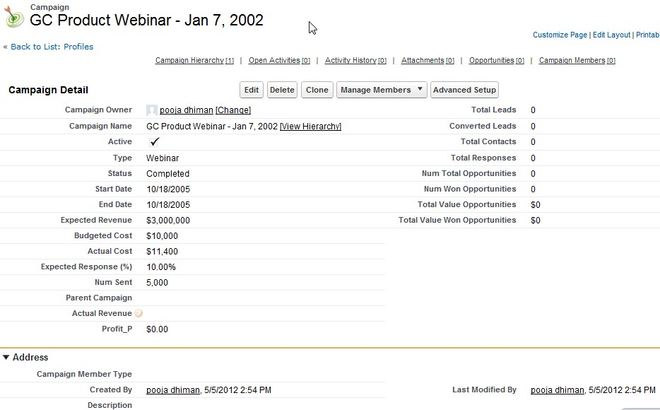

Campaign Hierarchy:
A campaign hierarchy allows you to group campaigns together within a specific marketing program or initiative, which enables you to analyze related marketing efforts more efficiently. You can create a campaign hierarchy by associating campaigns with one another using the Parent Campaign lookup field on the campaign detail page.
To view the hierarchy for a campaign, click View Hierarchy next to the Campaign Name field on the campaign detail page.
To set up campaign hierarchies, add the Parent Campaign field to your campaign page layout and enable the campaign hierarchy statistics fields. Campaigns are listed in descending order based on their hierarchy level.
A hierarchy can contain a maximum of five levels. Each campaign can have only one parent campaign but an unlimited number of sibling campaigns. The Campaign Hierarchy related list shows a maximum of two hierarchy levels: the parent campaign and its child campaigns. If a child campaign has children, those children do not appear in the related list but their data is included in the campaign hierarchy statistic field values.
The campaign hierarchy fields provide aggregate data for a parent campaign and all the campaigns below it in the campaign hierarchy, regardless of whether a user has sharing rights to a particular campaign within the campaign hierarchy.
All campaigns within a hierarchy must use the same currency.

Campaign Members:
With the Campaign Members related list, you can view, add, edit, or remove campaign members directly from a campaign detail page. The Campaign Members related list displays five campaign members by default. To display more members, click the Show more link.
For campaigns with campaign members created from both leads and contacts, you must have “Read” permission on leads and contacts to see all members. If you only have “Read” on leads, you will only see campaign members created from leads; if you only have “Read” on contacts, you will only see campaign members created from contacts.
The Manage Members drop-down button in the Campaign Members related list consists of:
Add Members - Search to add campaign members from a search.
Add Members - Import File to add campaign members by importing leads from a comma-delimited text file (.csv).
Edit Members - Search to view, update, or delete existing campaign members.
Update & Add Members - Import File to edit campaign member status using an import file.

Campaign members are created from lead, contact, or person account records. You can add and update up to 50,000 campaign members at a time.
You can add new members to a campaign:
- Individually from the Campaign History related list on a contact, lead, or person account detail page
- By searching for contacts and leads from the Manage Members page
- From a campaign, contact, person account, or lead report
- From a list view of existing contacts or leads
- From a CSV import file of new leads
- From a CSV import file of existing members

When you delete a campaign, all related events, tasks, and attachments are also deleted. Associated contacts, leads, person accounts, and opportunities are not deleted with the campaign.
New campaigns have two default member status values: “Sent” and “Responded”.
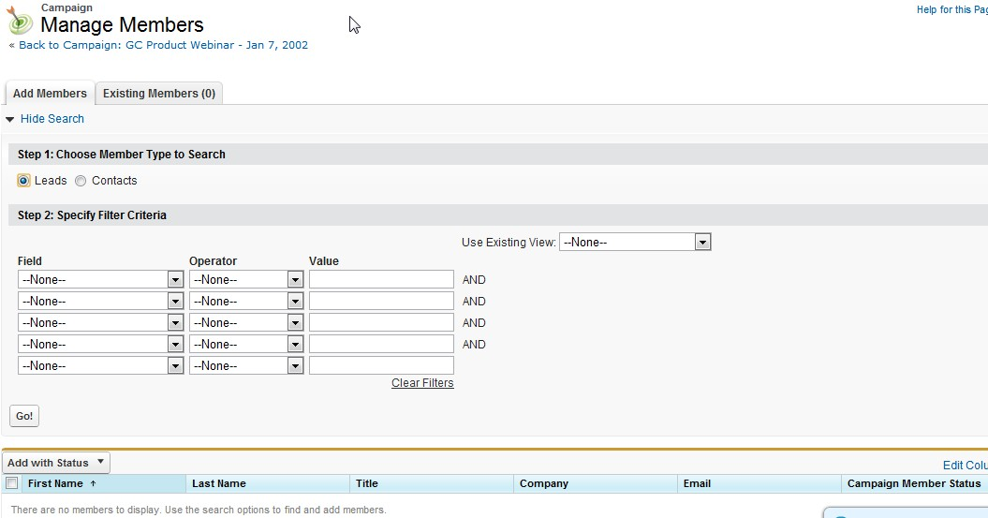

Service Cloud Applications | 6%
Describe the capabilities of case management
Given a scenario, identify how to automate case management
Describe the capabilities of solution management
Describe the basic capabilities of portals
Describe the capabilities of the Community application, such as Ideas and Answers
Describe the capabilities of Salesforce Knowledge

Ques: Describe the capabilities of case management?

Ans: Case management has following features:
- Customizing Fields
Create custom case fields to track information specific to your case management process.
- Customizing Case Page Layouts
Design your case page layouts to add or remove fields, buttons, and related lists.
- Creating Email Templates
Edit standard templates or build your own distinctive email templates to send to customers who submit cases.
- Defining Assignment Rules
Automatically route cases to the appropriate person or team.
- Setting Up Auto-Response Rules
Prepare automated responses to your incoming cases based on any attribute of the case.
- Setting Case Escalation Rules
Customize Salesforce to handle your case escalation process.
- Capturing Cases from Your Website
Design a form to post on your website that allows customers to submit cases.
- Capturing Cases from Customer Emails
Set up multiple customer support email addresses so incoming customer emails automatically generate cases.
- Customizing the Case Sharing Model
Select a sharing model that gives your users the access they need to cases.
- Setting Up Case Teams
Set up case teams so that teams of users can work on cases together.

Read case management implementation guide

Notes:

Why can’t I see sharing button?
The Sharing button allows users to extend the sharing of a record such as a lead, opportunity, or case. However, the Sharing button only displays when appropriate. The Sharing button is available when your sharing model is either Private or Public Read Only for a type of record or related record. For example, the Sharing button may appear on an account even though your sharing model for accounts is Public Read/Write if your sharing model for related opportunities is Public Read Only.

Why does the same search by different users return different results?
The reason two users may not have the same results for the same search is because each search is configured for the specific user. For example, if a user has recently viewed a record, that past viewing increases the relevancy of that record and moves it higher in the list of search results. Records also become more relevant if they are owned by the user performing the search, or if they are used frequently by other members of the organization.

Que: Describe the capabilities of the Community application, such as Ideas?

Ans: Salesforce CRM Ideas is a community of users who post, vote for, and comment on ideas. Consider it an online suggestion box that includes discussions and popularity rankings for any subject. On the Idea tab you can:
- Post ideas
- View ideas
- Search for ideas
- Vote for ideas
- Comment on ideas
- View recent activity and replies
- Subscribe to syndication feeds

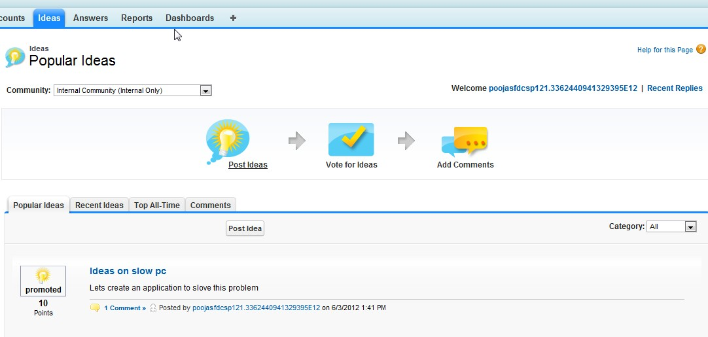

To make sure Salesforce CRM Ideas is enabled and to verify the default settings:
1. Click Your Name > Setup > Customize > Ideas > Settings.
2. To enable Salesforce CRM Ideas, select the Enable Ideas checkbox.
3. Optionally, select Enable Text-Formatting, Images and Links to enable the Salesforce CRM Ideas HTML editor
4. Optionally, enter a number of days in the Half-Life field. In most cases, the default value is sufficient. A shorter half-life moves older ideas down the page faster than a longer half-life.

There are multiple options available:
- Categorizing Ideas – helps to organize ideas into sub-groups within community. The View Category drop down list on ideas tab allow user to filter Ideas by categories and Categories picklist on Post Ideas page allows user to add categories to ideas.
- Displaying Idea’s Status – helps to track progress of the Idea. Under review, reviewed. Coming soon, Now Available are the common status and they appear next to the Idea’s title.
- Community Expert – when a community expert post or comment on ideas, a unique icon appears next to his name that help other to identify credible information within the community.

Capabilities of Ideas:
Creating communities: Your Name > Setup > Customize > Ideas > Communities to create new community. Page allows you to create and edit communities for ideas, answers, and Chatter Answers. Each community has its own unique ideas, questions and replies.
Defining Picklist Values for the Categories and Status Fields: Your Name > Setup > Customize > Ideas > Fields to define picklist values for the Categories and Status standard fields.
Creating Validation Rule: Your Name > Setup > Customize > Ideas > Validation rules to create new validation rule that helps to improve data quality by preventing users from saving incorrect data. You can define one or more validation rules that consist of an error condition and corresponding error message. Validation rules are executed at record save time. If an error condition is met, the save is aborted and an error message displayed.
Example uses:
- Make fields conditionally required, depending on the value of another field
- Ensure that numbers are within a specified range, such as discount is less than 30%
- Enforce that date fields are the correct chronological sequence, such as start date is before end date
Creating Validation Rules to Prevent Offensive Language: Your Name > Setup > Customize > Ideas > Comment Validation rules to create new validation rule using the table content below

Field | value
Description | Prevents users from entering offensive language when posting a comment.
Formula | OR(CONTAINS(CommentBody , 'darn'), CONTAINS(CommentBody,  'dang'))
Error Message | Comment contains offensive language

Ques: Describe the capabilities of the Community application, such as Answers?

Ans: Answers is a feature of the Community application that enables users to ask questions and have community members post replies. Community members can then vote on the helpfulness of each reply, and the person who asked the question can mark one reply as the best answer.

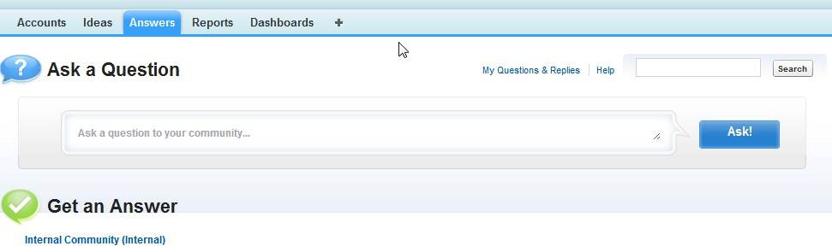
On the Answers tab you can:
- Ask a question
- Find an answer to a question
- Reply to a question
- Vote for a reply
- Identify a reply as the best answer to your question
- View all of your questions and replies
- Convert a reply into an article in the knowledge base
- Escalate a question to a case
The right side of the answers home page provides a snapshot of recent activity by showing the most recently asked and the most recently replied questions, as well as questions that have been open for more than a week.
Only administrators have full read, create, edit, and delete permissions for answers. Standard and portal users can delete their own questions and replies if no one has replied or voted.

To enable the answers feature:
Click Your Name | Setup | Customize | Answers | Settings.
Click Edit.
Use the Enable Answers checkbox to enable answers.
Enabling answers adds the Answers tab to the Community application and creates a community named Internal Community.
Select the default community for the Answers tab. You can only display one answers community at a time. You can either use Internal Community as the default or create a new community and use it as the default.
Click Save.
To create communities:
Click Your Name > Setup > Customize > Ideas > Communities to create new community. Page allows you to create and edit communities for ideas, answers, and Chatter Answers.

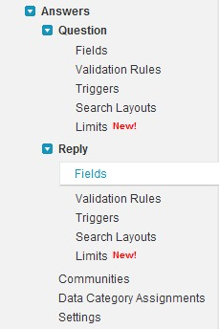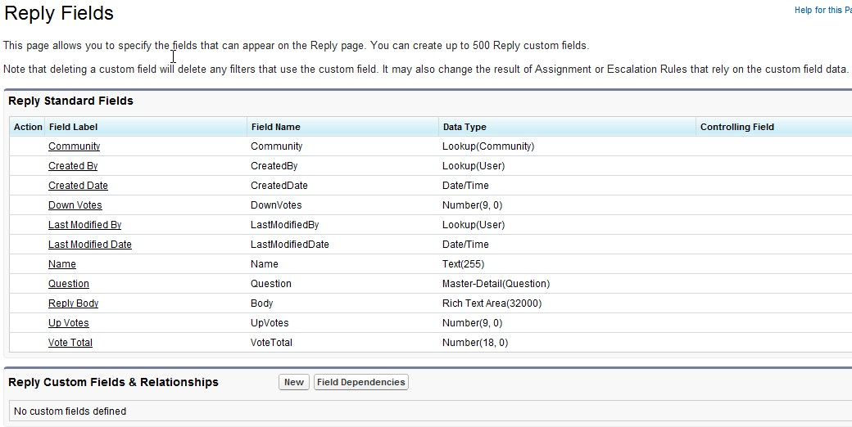
Assigning Data Categories to Answers:
After you create a category group and add data categories for your answers community, you need to assign the categories to answers:
1. Click Your Name > Setup > Customize > Answers > Data Category Assignments. The category group assignments page
only displays after you enable answers.
2. Click Edit.
3. Select the category group you want to assign to your answers community. You can only assign one category group to
answers and Save.

Ques: Describe the capabilities of Salesforce Knowledge?
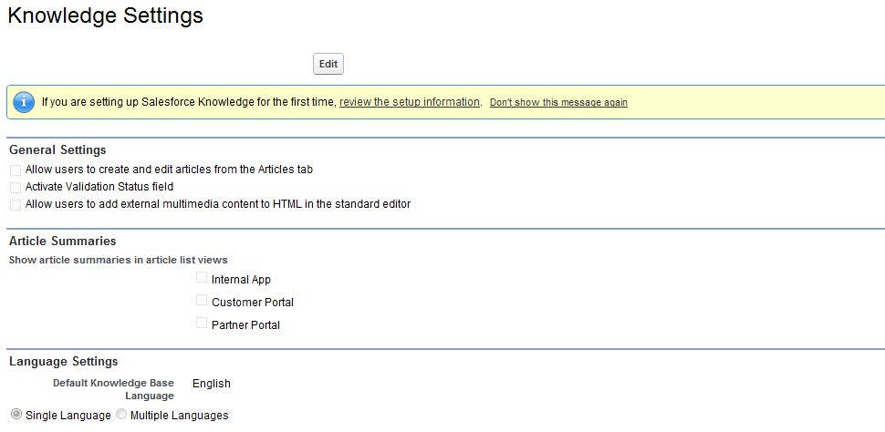
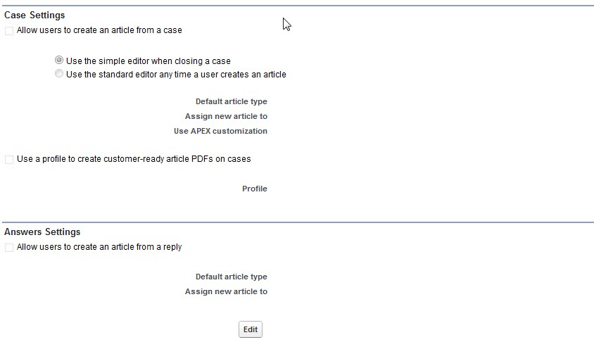
Ans: To enable salesforce knowledge base two things need to be considered:
1) Knowledge user checkbox is enabled on user detail page
2) Create article type

Data loader:
You have two options – Export Now and Schedule Export
If you click Export Now it will display the
Export file encoding (locale setting)
Include images, documents and attachments
Include chatter files, Salesforce CRM content document version
Replace carriage return with spaces
Data to include in your export (include all data if not sure)
Once click Export now, you request will be in queue and email will be sent to you when the export will be ready.

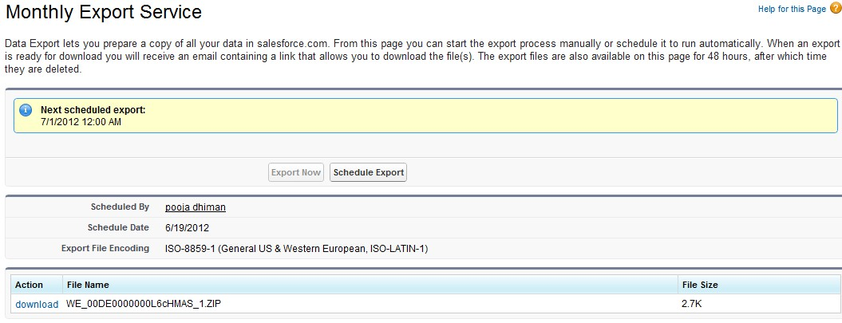
In Schedule export, you also see the option to set the frequency for export

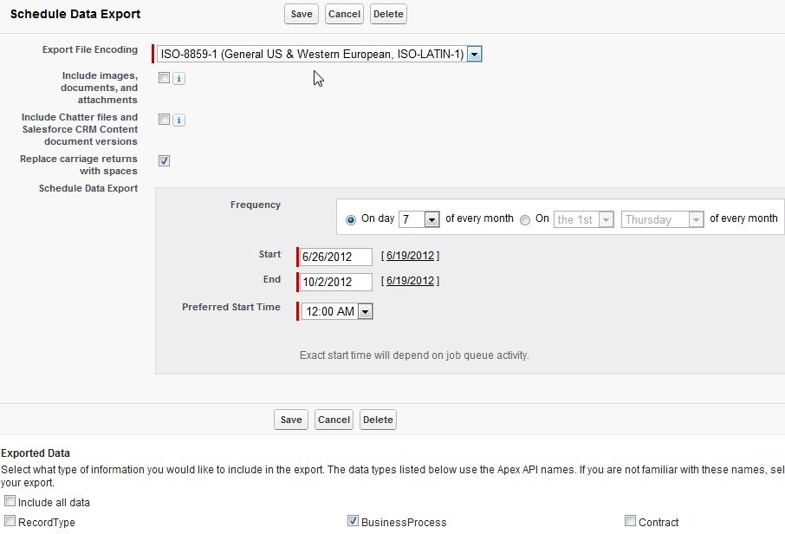

Analytics – Reports and Dashboards | 13%
Describe the options available when creating or customizing a report
Describe the impact of the sharing model on reports
Describe the options available when creating and modifying dashboards
Describe the capabilities of custom report types

Ques1: Describe the options available when creating or customizing a report?

Ans: Following are the options:

- Go to Name > Setup > Customize > Report & Dashboards > Report Folder or go to Reports Tab to create new report.
- Click New Report button
- Select Report type from the folder and click Create button. For e.g select Opportunities as report type if you want to create report for opportunities.
- Report Page has three divisions: Field pane, Filters pane and Preview Pane

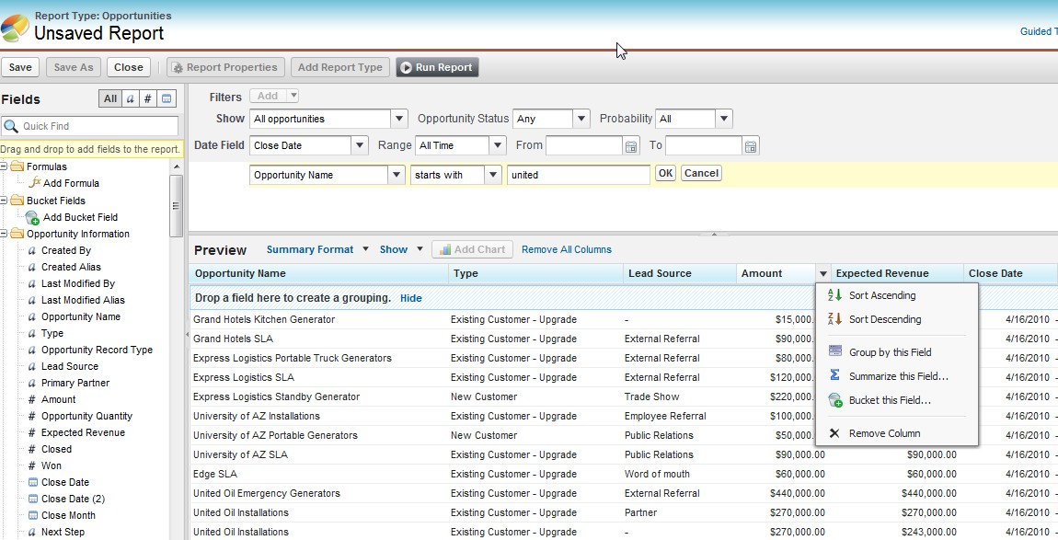

- In the Field Pane you can
- Search for fields by using quick search or select type of fields like numeric, text or date
- Add formulas
- Add Bucket fields
- Drag and drop to add fields to the report
- In the Filter pane you can
- Add filters such as Row Limit, Filter Logic, Field Filter e.g you want opportunities with name united only to appear in report so
- You can customize Show, Date and Range according to the report requirement.
- In the Preview Pane you can
- Select Format of report from tabular, Summary, Matrix or Joined
- You can utilize Show in Preview pane to see or hide Details, Drop Zones and can use Conditional Highlighting available for Summary and Matrix report
- In summary and Matrix report you also get the option to Add Charts
- Each column has menu which allows you to Sort, Group, Summarize, Bucket or Remove the column
- Click Save as to save the report
- Click Run report to run the report
- Click Close to close the report

Ques 2: Describe the impact of the sharing model on reports?

Ans: Reports are impacted by:

Report Folder
- Public Folder Access defines the permission to the report as Read Only or Read/Write to different set of user. Select the user access carefully to avoid unauthorized viewing. Choose the role that makes the most sense, or make the folder hidden or public.
- Use the same access permission for the Dashboards folder as for the Report Folder otherwise the user will not be able to view data.

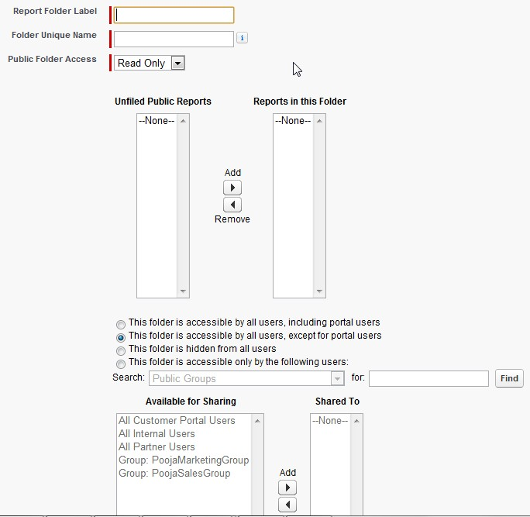

Profiles
Profile controls the following permission
- Administrative Permissions: Manage public reports, Schedule reports and Manage custom report types
- General permissions: Create and customize reports, Report Builder, Run Reports and Export reports

Chatter
Enabling chatter gives you feed tracking, following (for reports, dashboards, and components), alerts on metric and gauge components, and dashboard component snapshot posts. Snapshots posted to user or public group feeds can be seen by everyone in the company—even those without access to the dashboard.

User Permissions Needed
To create, edit, and delete reports: “Create and Customize Reports”
To create, edit, and delete dashboards: “Run Reports” AND “Manage Dashboards”
To create, edit, and delete public report folders: “Manage Public Reports”
To create, edit, and delete public dashboard folders: “Manage Dashboards” AND “View All Data”

Ques 3: Describe the options available when creating and modifying dashboards?

Ans: Dashboard builder is a drag-and-drop interface for creating and modifying dashboards. To create a new dashboard, Go to Name > Setup > Customize > Report & Dashboards > Report Folder or go to Dashboards Tab

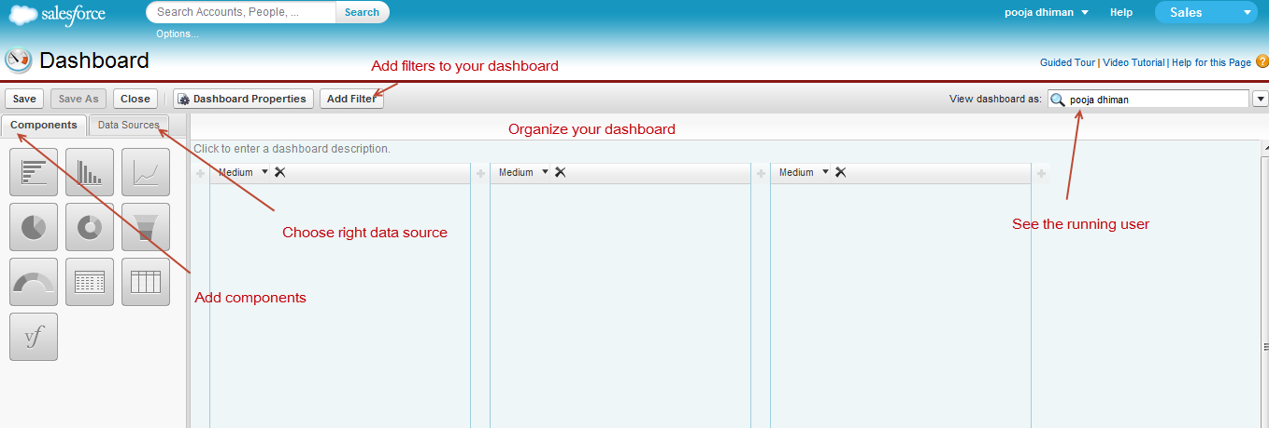

Dashboard builder has the following controls:

Dashboard-Level Controls
- Save or close the dashboard. You lose your changes if you close or navigate away from the dashboard builder without saving first.
- Click Dashboard Properties to change the title, unique name, folder, and component settings.
- View or set the running user for the dashboard.
- Click the text field at the top of the dashboard to add a description.

Component-Level Controls
Add components by dragging a component type (charts, gauge meter, pie, donut) onto a column, then dropping a data source (report, s-control, or Visualforce page) onto it.

Column-Level Controls
- On the dashboard that contains the component you want to change, click Edit.
- Click on your dashboard component.
- If necessary, change the component type.
- On the Component Data tab, choose which summary fields and groupings in the underlying report you want to display in your component. Click one of these chart icons to see your choices for that component type.

- On the Formatting tab, specify how your component shows its data. Your formatting choices depend on the component type you choose. Click a chart icon to see your formatting choices for that component type.
- Click OK.

Ques 4: Describe the capabilities of custom report types?

Ans: Custom report types allow you to build a framework in the report wizard, from which users can create and customize reports. You build custom report types off of the relationships (master-detail and lookup) between objects so that you can:
- Choose which standard and custom objects to display to users creating and customizing reports
- Define the relationships between objects displayed to users creating and customizing reports
- Select which objects' fields can be used as columns in reports

- Go to Name > Setup > Create > Report Types to create new custom report type.
- Specify the Report Type Focus. Example: If reporting on "Contacts with Opportunities with Partners," select "Contacts" as the primary object.
- Enter Report Type Label, Name, Description and Category to store report type in.
- Select Deployment Status. A report type with deployed status is available for use in the report wizard. While in development, report types are visible only to authorized administrators and their delegates.
- Add Child objects and relationships for report type. To do so, click the box under the primary object.
- Select a child object. Type in the search box to find objects quickly. Only related objects are shown.
- For each child object, select one of the following criteria:
  - Each "A" record must have at least one related "B" record. Only parent records with child records are shown in the report.
  - "A" records may or may not have related "B" records. Parent records are shown, whether or not they have child records.
When Users are the primary object, select child objects by field—for example, Accounts (Account Owner) or Accounts (Created By).
- Add up to three child objects. The number of children depends on the objects you choose.
- Click Save.

After you create a custom report type, you can customize, edit, and delete it from the All Custom Report Types page. After you click a custom report type name you can:
- Update which object relationships a report can display when run from the custom report type.
- Edit the layout to specify which standard and custom fields a report can display when created or run from the custom report type.
- Preview how the fields display to users in reports run from the custom report type by clicking Preview Layout on the Fields Exposed for Reporting section.
- Create a new custom report type with the same object relationships and fields as the selected custom report type by clicking Clone.
- Rename fields in the report.
- Set which fields are selected by default.
Important: When you delete a custom report type, any reports based off it will also be deleted. Furthermore, any dashboard components created from a report based off of a deleted custom report type display an error message when viewed.

Workflow Automation | 7%
Describe when workflow rules are evaluated
Describe the capabilities of workflow rules and actions
Given a scenario, identify the appropriate workflow solution
Describe capabilities and use cases for the approval process

Ques: Describe when workflow rules are evaluated?

Ans: Following are the conditions:
- When a record is created, or when a record is edited and did not previously meet the rule criteria: Choose this option to include new records and updates to existing records, unless the rule just ran and still meets the rule criteria. The rule isn't re-triggered on edits that don't affect rule criteria. For example, if setting an opportunity rating to “Hot” causes the rule to run, with this option, the rule runs again only if the rating changes, then changes back to “Hot”—no matter how many times you edit the object.
- Only when a record is created: Choose this option to ignore updates to existing records.
- Every time a record is created or edited: Choose this option to include new records and updates to existing records and repeatedly trigger the rule, even if the record still meets the criteria.

Ques: Describe the capabilities of workflow rules and actions?

Ans: Workflow automates the following types of actions based on your organization's processes:
- Tasks—Assign a new task to a user, role, or record owner.
- Email Alerts—Send an email to one or more recipients you specify.
- Field Updates—Update the value of a field on a record.
- Outbound Messages—Send a secure, configurable API message (in XML format) to a designated listener.
For example, workflow can:
- Assign follow-up tasks to a support rep one week after a case is updated.
- Send sales management an email alert when a sales rep qualifies a large deal.
- Change the Owner field on a contract three days before it expires.
- Trigger an outbound API message to an external HR system to initiate the reimbursement process for an approved expense report.
Each workflow rule consists of:
- Criteria that cause the workflow rule to run.
- Immediate actions that execute when a record matches the criteria. For example, salesforce.com can automatically send an email that notifies the account team when a new high-value opportunity is created.
- Time-dependent actions that queue when a record matches the criteria, and execute according to time triggers. For example, salesforce.com can automatically send an email reminder to the account team if a high-value opportunity is still open ten days before the close date.

- Go to Name > Setup > Create > Workflow & Approvals > Workflow Rule to create new workflow rule.
- Select object for which workflow is created.
- Enter name and description for the rule.
- Select Evaluation Criteria from the options:
- Enter Rule criteria by selecting:
  - Criteria are met and select the filter criteria that a record must meet to trigger the rule. For example, set the filter to “Opportunity: Amount greater than 5000” if you want opportunity records with an amount greater than $5,000 to trigger the rule.
  - Formula evaluates to true and enter a formula that returns a value of “True” or “False.” Salesforce triggers the rule if the formula returns “True.”
- Specify what action should take place when workflow rule is evaluated. You can select:
  - Immediate workflow action that allows you to send email alert, outbound message, create new task and make field update
  - Time dependent workflow action for which you have to specify a number of days or hours before or after a date relevant to the record, such as the date the record was created or modified. If the workflow rule is in effect when this time occurs, the time trigger fires the workflow action.
- Once the rule is created, Activate the workflow rule.

Que: Given a scenario, identify the appropriate workflow solution?

Ans: For different scenarios, this is how workflow solution works:

- Send Alert if Quote Line Item Discount Exceeds 40%

Object | Quote Line Item
Description | Ensure that an email alert is sent if a sales rep applies a quote line item discount that exceeds 40%.
Evaluation Criteria | When a record is created, or when a record is edited and did not previously meet the rule criteria.
Rule Criteria (Filter) | Run this rule if the following criteria are met:  Quote Line Item: Discount is greater than 40
Immediate Actions | Email Alert: Notify the manager role that the quote line item discount exceeds 40%.
Time Dependent Action | None

- Setting Default Opportunity Name
The opportunity naming convention for some companies is Account Name: Opportunity Name. To automate the default name of each opportunity in your organization, create the workflow rule below.

Object | Opportunity
Description | Enforce opportunity naming convention.
Evaluation Criteria | Every time a record is created or edited.
Rule Criteria (Filter) | Run this rule if the following criteria are met:  NOT(CONTAINS( Name, Account.Name ))
Immediate Actions | Field Update: Set opportunity name to the following formula:  Account.Name & ": " & Name.
Time Dependent Action | None

- High Value Opportunity

Object | Opportunity
Description | Remind the opportunity owner and senior management when the close date is approaching for a large deal, an opportunity that has an amount greater than $10,000. Also, create a follow-up task for the opportunity owner if the deal is still open when the close date passes.
Evaluation Criteria | When a record is created, or when a record is edited and did not previously meet the rule criteria.
Rule Criteria (Filter) | Run this rule if the following criteria are met:  (Opportunity: Amount greater than 100000) and  (Opportunity: Closed equals False)
Immediate Actions | None
Time Dependent Action | 30 Days Before Opportunity: Close Date—Email Alert: Notify the opportunity owner that 30 days remain.  15 Days Before Opportunity: Close Date—Email Alert: Notify the opportunity owner that 15 days remain.  5 Days After Opportunity: Close Date—Task: Create a follow-up task for the opportunity owner to update the deal. Email Alert: Notify senior management to involve executives.

- Notify Account Owners of Updates by Others

Object | Account
Description | Notify the account owner when someone else updates the account if the account's annual revenue is greater than $1,000,000.
Evaluation Criteria | Every time a record is created or edited..
Rule Criteria (Filter) | Run this rule if the following formula evaluates to true:  AND( (LastModifiedById <> CreatedById), (AnnualRevenue > 1000000) )
Immediate Actions | Email Alert: Notify the account owner that someone else has updated the account.
Time Dependent Action | None.

Que: Describe capabilities and use cases for the approval process?

Ans: An Approval Process is an automated process your organization can use to approve records in Salesforce. It specifies the steps necessary for a record to be approved and who must be the approver at each step. It also specifies the action to take when record is approved, rejected, recalled or first submitted for approval. Your business runs more efficiently with automated processes. For example, you may already have workflow rules that automatically send email alerts or assign tasks based on your internal processes. Approvals take automation one step further, allowing you to specify a sequence of steps that are required to approve a record.
For example, your organization may have a two-step process for approving expenses: submitted expenses that are less than $50 are automatically approved, those over $50 must be approved by a manager, and those over $5,000 must also be approved by a Vice President. In this example, your approval process would specify the following:
- If an expense record is submitted for approval, lock the record so that users cannot edit it and change the status to “Submitted.”
- If the amount is $50 or less, automatically approve the request.
- If the amount is greater than $50, send an approval request to the direct manager.
- If the amount is greater than $5,000 and the first approval request is approved, send an approval request to the Vice President.
- If all approval requests are approved, change the status to “Approved” and unlock the record.
- If any approval requests are rejected, change the status to “Rejected” and unlock the record.

Approval processes require planning and preparation. Before you create an approval process, following are few steps:
- Determine which wizard is best for your needs.
  - Jump Start Wizard - The jump start wizard is useful for simple approval processes with a single step.
  - Standard Wizard - The standard wizard is useful for complex approval processes.
- Prepare approval request email template and post template.
- Determine approval request sender and approver.
- Determine the actions when an approval request is approved or rejected.

Scenario: Whenever an invoice greater than $2000 is created, it needs to be approved by the manager.

- To Create new approval process, go to Name > Setup > Create > Workflow & Approvals > Approval Processes
- Select object for which approval process is created from Manage Approval Processes For drop down list
- Click Create New Approval Process and choose the wizard. We select Standard Wizard.
- Specify Name, Unique Name, and Description for the process.
- Specify Entry Criteria. Here you have two options:
  - Criteria are met
  - Formula evaluates to true
For this process, we select Criteria are met. We enter Invoice value greater than 2000
- Specify Approver Field and Record Editability - When you define approval steps, you can assign approval requests to different users. One option is to use a user field to automatically route these requests. For this one, we can Use Manager.
- Select Notification template. Choose a custom email template to use when notifying approvers that an approval request is assigned to them, or leave this field blank to use the default email template.
- Select fields to display on Approval page layout. The approval page is where an approver approves or rejects a request.
- Specify which users are allowed to submit records for approval. For example, choose Owner if expense reports can only be submitted by record owners.
- Once approval process is created, you can set Initial Submission status, Final Approval status and Final rejection status.
- Activate the approval process once it is created.

Desktop and Mobile Administration | 2%
Describe the capabilities of Mobile Lite
Describe the installation and synchronization options of Salesforce for Outlook

Que: Describe the capabilities of Mobile Lite?

Ans: Mobile Lite is a free, restricted version of Salesforce Mobile that is available to any Salesforce user who doesn't have a mobile license. Mobile Lite users can view, create, edit, and delete accounts, assets, contacts, leads, opportunities, events, tasks, cases, and solutions. They also have access to their dashboards. Salesforce Mobile allows users to quickly look up a contact and -- with one click -- place a phone call or send an email, then log the call or email directly into salesforce.com. Users can make appointments, create and assign tasks, follow up on leads, work on cases and much more, all conveniently from their mobile device.

To deploy Mobile Lite, first enable Mobile Lite by going to Name > Setup > Mobile Administration > Salesforce Mobile > Settings. After that, configure the Mobile Lite. Mobile configurations determine the data salesforce.com transmits to users' mobile devices, and which users receive that data on their mobile devices.

- Go to Name > Setup > Mobile Administration > Salesforce Mobile > Configuration to access configurations list page.
- Click New Mobile Configuration.
- Enter name and description for the mobile configuration.
- Select the Active checkbox if you want to activate the mobile configuration immediately after creating it.
- Assign Users and Profiles - Select the salesforce.com users and/or profiles that will use this mobile configuration. A user profile may have only one mobile configuration. Configurations assigned to individual users will override any configurations assigned to user profiles.
- Set Data Size Limit - To avoid overloading mobile devices, specify the maximum data size allowed for all data sets combined in this mobile configuration. Salesforce.com will not synchronize any data sets if the combined data size exceeds this limit. Test the configuration to verify the same.
- After creating mobile configurations, send a mass email to mobile users explaining how to register their mobile devices. The registration process creates device records in Salesforce, which allows you to manage your organization's mobile devices.

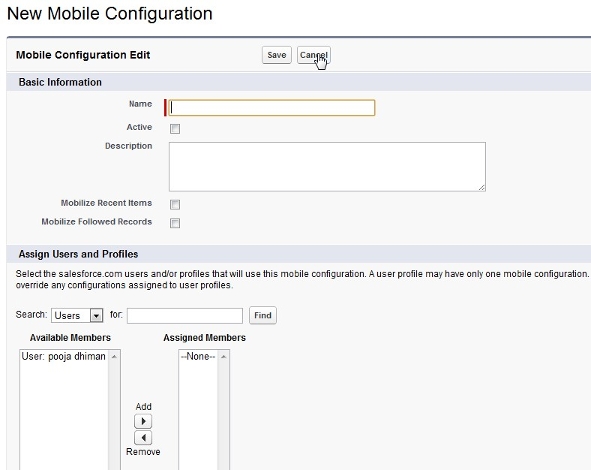

Mobile Lite is a free, restricted version of Salesforce Mobile that is available to any Salesforce user who doesn't have a mobile license.
Mobile Lite users can view, create, edit, and delete accounts, assets, contacts, leads, opportunities, events, tasks, cases, and solutions. They also have access to their dashboards.
You can enable Mobile Lite for your organization by editing your mobile settings. The mobile settings also let you control whether Mobile Lite users have access to all available CRM tabs, or just to dashboards.
Starting with Spring '09, Mobile Lite is enabled by default in all new organizations. You can disable Mobile Lite to prevent users from accessing Salesforce from a mobile device.
Mobile Lite:
- Supports fewer standard objects
- Doesn't provide support for custom objects
- Doesn't allow administrators to customize or create mobile configurations
Mobile Lite users are automatically assigned to the default mobile configuration when they activate their Salesforce account from a supported mobile device. Mobile configurations determine the data sent to each mobile user. Administrators can't view or edit the default mobile configuration.
Note

Mobile Lite is not supported for partner portal users.

Que: Describe the installation and synchronization options of Salesforce for Outlook?

Ans: Salesforce for Outlook is a Microsoft® Outlook® integration application that lets you log emails in Salesforce. You can also sync contacts, events, and tasks between Outlook and Salesforce. Settings are stored in configurations in Salesforce and may be editable for certain users.

To make configured Salesforce for Outlook available for user, admin has to create configuration. To create configuration, follow the steps:
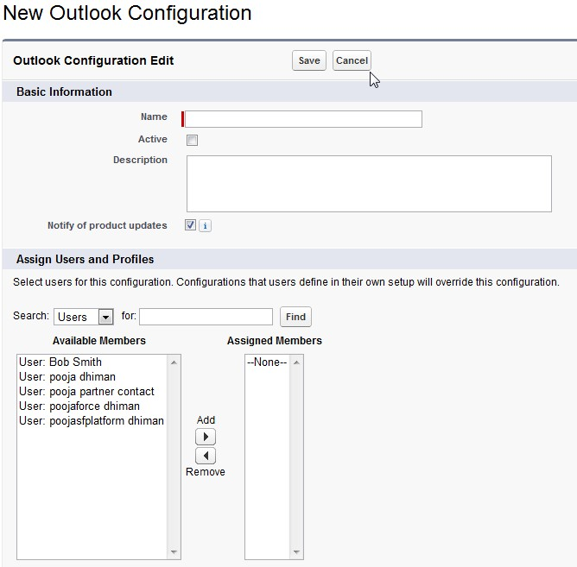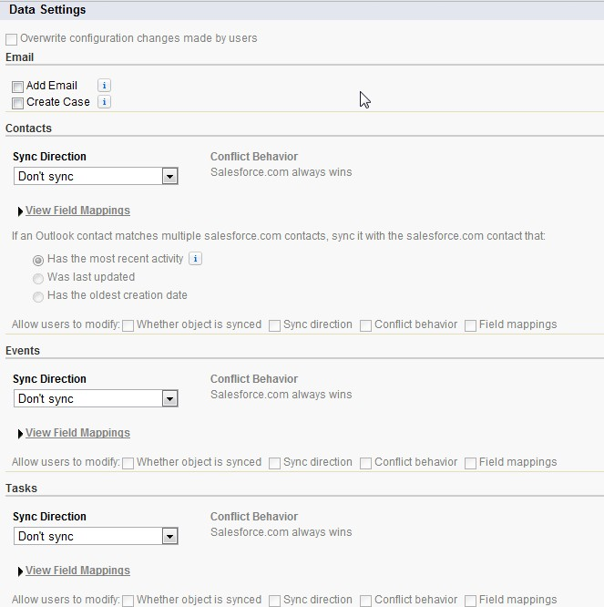

- Click Your Name | Setup | Desktop Administration | Outlook Configurations.
- Click New Outlook Configuration.
- Enter a name and description of the configuration.
- Select Active to activate the configuration.
- Make sure Notify of product updates is selected if you want users to see system tray alerts when new versions of Salesforce for Outlook are available for download.
- Assigned users and profiles
- Add email and create cases
- Sync directions – it has three option:
  - Don't sync—Outlook and Salesforce records aren't synced, and you can't select an Outlook folder to sync within the setup wizard.
  - Salesforce.com to Outlook—When data first syncs, a record in Salesforce creates or updates a record in Outlook. During future syncs, changes made to Salesforce records appear in Outlook, regardless of whether the Outlook version of the record has changed. In addition, deleting a synced record in Salesforce deletes its Outlook counterpart. Outlook changes are never sent to Salesforce. The required conflict behavior setting for this option is Salesforce.com always wins.
  - Outlook to salesforce.com—During its first sync, a record in Outlook creates or updates a record in Salesforce. During future syncs, changes made to Outlook records appear in Salesforce, regardless of whether the Salesforce version has changed. In addition, deleting a synced record in Outlook deletes its Salesforce counterpart. Salesforce changes are never sent to Outlook. The required conflict behavior setting for this option is Outlook always wins. This option isn't available for contacts.
  - Sync both ways—When records sync, changes to Outlook records are reflected in Salesforce, and vice versa. If records conflict, the conflict behavior setting determines which record wins.
- Field mappings
- Matching criteria
- Modification permissions
- Advanced settings

Defining Data sets
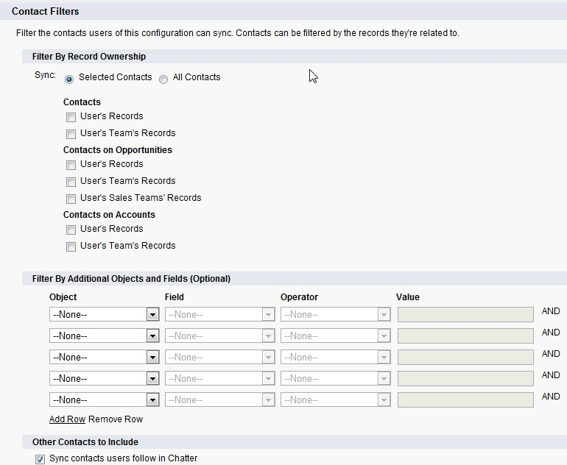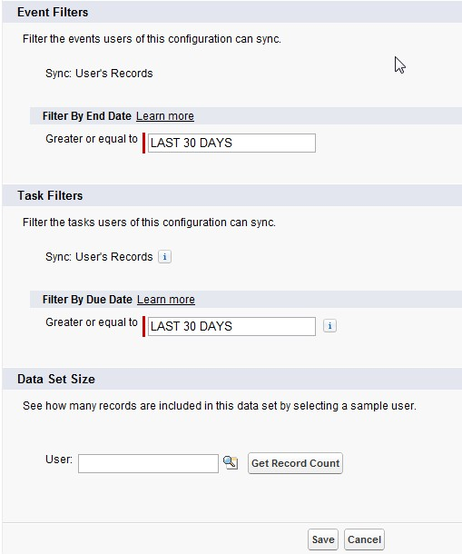

Once configuration is done, Users can modify these configurations as per use. Following are the simple step for installing Salesforce for Outlook:
- Go to Personal Set Up > Desktop Integration > Salesforce for Outlook
- Click View my configuration to see the settings and the click Download to install Salesforce for outlook.
- Open Outlook. The setup wizard opens, and the Salesforce for Outlook icon () appears in your system tray. To manually open the wizard, right-click this icon and click Settings.
- Enter your Salesforce username and password.
- Click Approve. This creates a secure connection between Outlook and Salesforce.
- Click Next, and choose the folders you want to sync. You can use your default folders or click Change Folder and select or create a folder that's within your default folders or the main Mailbox folder.
- Click Next, and then choose options for private items you want to sync.
- Click Save. A welcome message appears at the system tray icon (), which is now active. If you're configured to sync Outlook items, all data in your selected folders syncs automatically. The icon spins to let you know when data is syncing.
During active use, all updates sync automatically every ten minutes. If we detect no keyboard or mouse activity for 30 minutes, we change the sync frequency to 30 minutes. After two hours of inactivity, we sync hourly, and after four hours, we sync every four hours.

Synchronization:
How contacts sync when the sync direction is Salesforce.com to Outlook:

If | Then
A contact already exists in Outlook | The Salesforce contact replaces the Outlook contact and the two are synced.
A contact doesn't exist or has been deleted in Outlook | The contact is automatically created in Outlook and the two are synced.
Multiple matching contacts exist in Outlook | We select one of them.
A contact is updated | The Salesforce contact always overwrites the Outlook contact, regardless of which one was updated.
A Salesforce contact is deleted | The Outlook counterpart is also deleted. If the Outlook contact is deleted and the Salesforce contact is updated, the contact is recreated in Outlook.

How contacts sync when the sync direction is Sync both ways:
If | Then
A contact exists on one side only | The contact is automatically created on the other side and the two are synced.
A matching contact exists | One contact record replaces the other one, and the records are synced. If your Outlook configuration specifies that Outlook contacts win, the Outlook version replaces theSalesforce version, and vice versa if Salesforce is set to win. Any change to either record is automatically reflected in the other. If records conflict, the conflict behavior setting determines which record wins.
Multiple matching Salesforcecontacts exist | As long as there's only one version of the Outlook contact and that contact has an email address, we sync the Outlook contact with aSalesforce contact based on your matching preference, such as the contact that was most recently updated.
A contact is updated | Both contacts are updated with the latest changes. If records conflict, the conflict behavior setting determines which record wins.
A Salesforce contact is deleted and the Outlook contact is updated | The Outlook counterpart is deleted if Salesforce is set to win, and the contact is recreated in Salesforce if Outlook is set to win.
An Outlook contact is deleted and the Salesforce contact is updated | The Salesforce counterpart is deleted if Outlook is set to win, and the contact is recreated in Outlook if Salesforce is set to win.

Syncing Events:
Your Outlook configuration defines which items are set to sync, which direction the data flows between Outlook and Salesforce, and what happens when data conflicts. The event filters in your configuration determine which events sync. The possible filters are:
- TODAY—Syncs events that end on or after today. The start time is 12:00 a.m.
- LAST MONTH—Syncs events that ended on or after the first day of last month.
- LAST N DAYS—Syncs events that ended on or after a specified number of days ago, such as LAST 30 DAYS.

AppExchange | 2%
Identify use cases for AppExchange applications

Que: Identify use cases for AppExchange applications?

Ans: The AppExchange is salesforce.com’s one-stop-shop for business applications that you can quickly and easily add to your Salesforce CRM account for added business functionality. Just like you browse for music on iTunes, you can browse the AppExchange for business applications that plug right into Salesforce CRM.
Use case 1
VP of sales wants to use SMS service on his opportunities tab but SMS is not available in Sales force so we can go to Appexchange to find this functionality and follow below mentioned steps to add it.
- Go to the AppExchange Web site
- Navigating AppExchange – You can search for specific apps using the toolbar on the left-hand side of the page or you can browse by categories.
- Enter SMS in search field. Result page will display all the available apps related to SMS. Select one of them based on requirement. We select SMS Magic based on pricing and rating.
- Click the red Get It Now button on the right side of the page.
- Choose the Production Environment to install the application.
- Click OK.
- Log in to Salesforce CRM – If you are not already logged into your Salesforce CRM application, you’ll be asked to log in.
- Click the checkbox to Accept Terms & Conditions.
- Click the red Install button.
- Enter your Password as another verification.
- Click Submit.
- Click Continue after reviewing the different components that are about to be installed.
- Review all the packages that will be installed and then click Next.
- Click Install.
- Once installed, application is ready to use after integration.

